Asian Honey-Tea Grilled Prawns

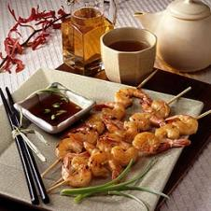

Nutritional Information

* **per serving (1/4 of recipe)**
* **Calories: 202**
* **Total Fat: 3 g**
* **Cholesterol: 259 mg**
* **Sodium: 511 mg**
* **Total Carbohydrates: 7 g**
* **Dietary Fibre: > 1 g**
* **Protein: 35 g**
* **Calories from Fat: 13%**

Ingredients

* 1-1/2 lbs. - medium shrimp, peeled and deveined
* Salt
* 2 - green onions, thinly sliced
* 1 cup - brewed double strength orange spice tea, cooled
* 1/4 cup - honey
* 1/4 cup - rice vinegar
* 1/4 cup - soy sauce
* 1 Tablespoon - fresh ginger, peeled and finely chopped
* 1/2 teaspoon - ground black pepper

Directions

In plastic bag, combine marinade ingredients (everything but the shrimp, salt and onions). Remove 1/2 cup marinade; set aside for dipping sauce. Add shrimp to marinade in bag, turning to coat. Close bag securely and marinate in refrigerator 30 minutes or up to 12 hours. Remove shrimp from marinade; discard marinade. Thread shrimp onto 8 skewers, dividing evenly. Grill over medium coals 4 to 6 minutes or until shrimp turn pink and are just firm to the touch, turning once. Season with salt, as desired. Meanwhile, prepare dipping sauce by placing reserved 1/2 cup marinade in small saucepan. Bring to a boil over medium-high heat. Boil 3 to 5 minutes or until slightly reduced. Stir in green onions.