Baked Honey Ham

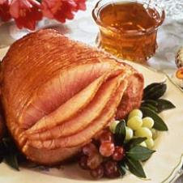

Nutritional Information

* **Calories: 341**
* **Fat Total: 8.7 g**
* **Protein: 34.1 g**
* **Cholesterol: 79 mg**
* **Carbohydrates: 32.4 g**
* **Sodium: 2301 mg**
* **Dietary Fibre: 0.2 g**
* **Calories from Fat: 23%**

Ingredients

* 1 Tablespoon - flour
* 1 - oven cooking bag
* 1 (about 6 lbs.) - bone-in fully cooked ham
* 16 oz. (1-1/4 cups) - honey
* 4 teaspoons - lemon pepper
* 2 teaspoons - rosemary or thyme, crushed
* Honey Sauce, recipe follows

Directions

Place flour in roasting bag and shake to coat inside surface. Place ham in floured bag. Combine honey, lemon pepper and rosemary; pour over ham and close bag with twister. Poke holes in top of bag with fork. Roast at 325°F for 1 to 1-1/2 hours or until slightly browned. Remove from oven, let stand 10 minutes. Cut bag and remove ham, following bag manufacturer's directions. Reserve drippings for sauce. Honey Sauce: Strain drippings and measure; add enough water to equal 2 cups. Add 1/2 cup white wine and bring to boil. Serve with ham. Makes 12 servings. Honey Sauce Nutrients per Serving Calories: 13 Fat Total: 0.1 g Protein: 0.5 g Cholesterol: 0 mg Carbohydrates: 1.1 g Sodium: 20 mg Dietary Fibre: 0 g Calories from Fat: 12%