Body Moisturizer with Honey

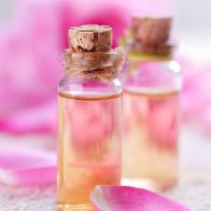

YIELD: MAKES TWO APPLICATIONS

Ingredients

* 5 tablespoons - honey
* 2 tablespoons - rose oil
* 2 cups - almond oil

Directions

In a medium sized amber bottle, add honey, rose oil and almond oil. Cover tightly and mix by gently shaking the bottle; if necessary, uncover and stir with a thin utensil. Use moisturizer in the shower by applying onto wet skin, especially concentrating on dry areas.