**Clearing the Supers of Bees.**

Michael Birt.

The Porter Bee Escape was invented in 1891 by Edward Porter, and is a very effective method of removing bees from a super if used correctly.

Correctly means using a minimum of 2 escapes in a crown board the correct way up – most have top written on them - if not, fit it with the single hole on top! Additionally the spring must be adjusted so there is a 3mm gap between each pair of springs.

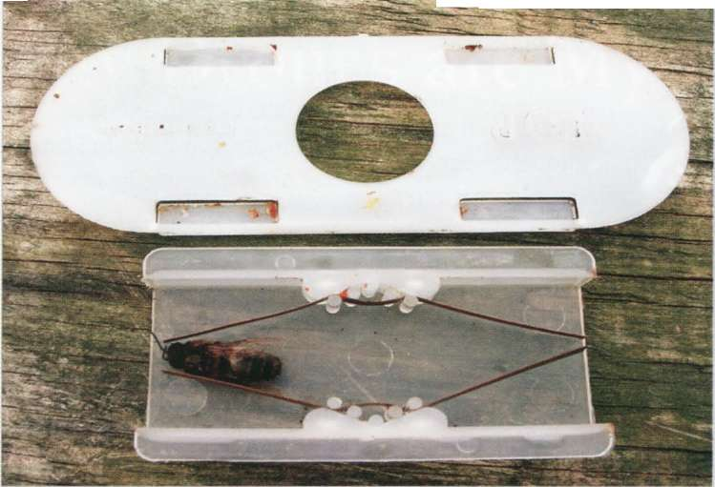

To use the board you must provide enough space for the bees to evacuate to so it is no good just placing the clearer board on top of the brood box.

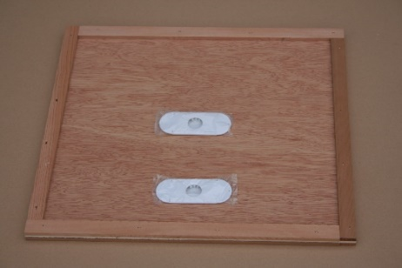

Any colony that has collected a super full of honey will be strong and populous. You must add another super below the clearer board for the bee to collect and cluster in - this must obviously not be a full super. Effective precautions must be taken to ensure the super is bee tight so place another crown board on top (sealing off any feeder holes) and use gaffer or masking tape to cover any bee sized gaps.

Do not rely on just a roof as they often have faulty ventilators and/or fit loosely. The board works best on a warm day when there is a flow on and most of the bees will clear in 24 hours; any straggler can be shaken out. Sometimes if the weather is poor they may be reluctant to leave the super but before you blame the weather, as all ‘Englishmen’ do, check that there is no brood in the super.

Bees will not desert their young and many times I have found supers still full of bees because of a faulty queen excluder allowing the queen access to the super(s). I always now (well when not in a rush!) check the center two frames in the first super for brood – finding brood needs other actions not relevant to this article. An addition problem is that some brood may be drone brood and drones being bigger will block the escape springs. How many boards do I need? Well in my experience placing a pile of supers over a single clearer board will not work so if you have four supers to clear place TWO empty supers below a clearer board topped with the first TWO supers to be cleared.

Then add another clearer board with the other TWO supers on top before sealing the pile. If you have three supers to clear the order is clearer, ONE super, clearer, TWO supers and a sealed crown board. Do not try to clear more than four supers and it is better to just clear them in pairs.

Clearing multiple supers only works in warm weather with a good flow on so be warned.