Coconut Cream Honey Eggnog

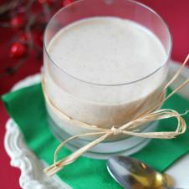

YIELD: 4 SERVINGS

Ingredients

* 3 tbsp. - honey
* 1 cup  - coconut milk
* ½ cup  - condensed milk
* 1 cup - evaporated milk
* 2 - egg yolks
* 2 tsp.  - cinnamon, ground
* 1 cup  - rum, (optional)

Directions

Place the three milks, the cinnamon and the yolks in a blender and blend. Next, pour the mixture into a medium-sized saucepan and cook over low-medium heat for about 5 minutes. Add the rum and cook for another 5 minutes. Remove from the heat and strain to eliminate any solid residue. Store the eggnog in the refrigerator for 5 to 8 hours before serving.

*\*The rum can be left out for a kid-friendly version.*