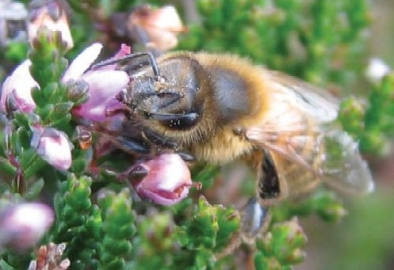


Animal & Plant Health Agency

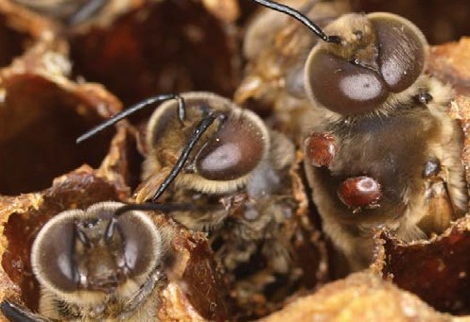
Managing Varroa

Pollination

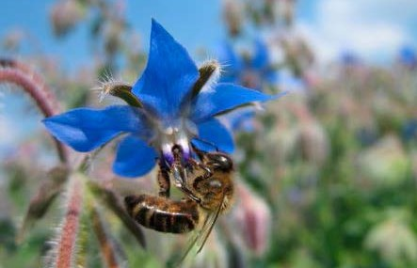
Pollinating insects provide almost incalculable economic and ecological benefits to humans, flowering plants and wildlife. Pollination by bees and other insects is the first step in the flowering/ fruiting process resulting in the production of vegetables and fruits. This essential nutrition comprises approximately 35% of the human diet. The production of 84% of crop species cultivated in Europe depends directly on pollinators. 70% of the 124 main crops used directly for human consumption in the world are dependent on pollinators.

Honey bee foraging on borage

The Animal and Plant Health Agency, National Agri-Food Innovation Campus, Sand Hutton
York, YO411LZ UK

Telephone +44 0300 3030094
Fax +44 (0)1904 462 111
Email NBU@apha.gsi.gov.uk
Website https://www.gov.uk/government/organisations/animal-and-plant-health-agency

© Crown copyright 2015

Copyright in the typographical arrangement and design rests with the Crown.

This publication (excluding the logo) may be reproduced free of charge in any format or medium provided that it is reproduced accurately and not used in a misleading context. The material must be acknowledged as Crown copyright with the title and source of the publication specified.

This document is also available on BeeBase (National Bee Unit) website, www.nationalbeeunit.com

Published by The Animal and Plant Health Agency. Printed in the UK, 2015, on material containing 80% post-consumer waste and 20% Elemental Chlorine Free pulp.

About this leaflet

Managing Varroa
Since its discovery in England in 1992 the parasitic mite, Varroa destructor, has spread to infest colonies of honey bees throughout the UK. Its management has now become a routine and essential part of bee husbandry. The development of strains of mite resistant to treatments used against them poses new challenges to beekeepers. This leaflet describes the biology of the mite, how it can be recognised and monitored, the latest approaches beekeepers can use to control the infestation in their hives, and a look ahead to the future.

Varroa destructor was first reported in Western Europe in the late 1970s. The mite causes varroosis, a very serious and complex infestation of honey bees. It has caused massive economic losses and expense for beekeepers, and its destructive power is evident from the huge number
of colonies lost since it first arrived in Europe. Varroa remains the number one management problem for beekeepers and scientists alike. The onset of resistance to the treatments available, and the potential impact of secondary infections, will make controlling the mite more difficult in the future. Varroa will continue to be a serious threat to the long-term sustainability and prosperity of European apiculture and to the environment through the disruption to pollination.

Acronyms
ABPV Adult Bee Paralysis Virus
APHA Animal and Plant Health Agency BBKA British Beekeepers’ Association BDI Bee Disease Insurance Ltd
BFA Bee Farmers’ Association
DARDNI Department of Agriculture and Rural Development Northern Ireland Defra Department for Environment, Food and Rural Affairs.
DLC Disease Liaison Contacts
IPI Insect Pollinators Initiative
IPM Integrated Pest Management
ISO International Standards Organisation MAQS Mite Away Quick Strips
MAVIS Marketing Authorisation Veterinary Information Services MRL Maximum Residue Limit
NBI National Bee Inspector
NBU National Bee Unit
OIE World Organisation For Animal Health OMF Open Mesh Floor
RBI Regional Bee Inspector
SASA Science and Advice for Scottish Agriculture SBI Seasonal Bee Inspector
SIC Special Import Certificate
SQP Suitably Qualified Person
VMD Veterinary Medicines Directorate VMP Veterinary Medicines Product VRC Veterinary Residues Committee WBKA Welsh Beekeepers’ Association

Contents

About this leaflet iii
Contents 1
Help and advice 3
The National Bee Unit 3
BeeBase 3
Why is it so important to register on BeeBase? 4
How to sign up to BeeBase 4
How do I know that my details are secure? 4
Beekeeping Associations 4
Introduction to Varroa 5
What is Varroa? 5
Why is it a problem? 5
Where is it found? 5
How did it get to the UK? 5
Do I have to report the presence of Varroa in my colonies? 5
Can Varroa be eradicated or controlled? 5
How do I know how badly infested my colonies are? 5
What control methods are available? 5
Varroa Biology 6
What are ‘pyrethroid resistant’ mites? 6
Feeding 6
Reproduction 6
Life-span 7
How Varroa spreads 7
Varroa lifecycle diagram 8
Harmful effects of Varroa 9
Effects on individual bees 9
Varroa, viruses and other pathogens 10
Effects on colonies 10
The signs of colony collapse 11
Harmful mite population threshold 11
Mite invasion pressure 11
Varroa population increase 11

How to recognise and monitor Varroa 14
Recognising Varroa 14
Monitoring Varroa 15
Monitoring tips 15

How to monitor colonies for Varroa 16
How to control Varroa infestation 17
The aim of Varroa control 17
Types of control 17

Using biotechnical controls 18
Using varroacides 22
‘Hard’ versus ‘Soft’ varroacides 22
Authorised varroacides 22
Use of non-approved generic substances 22
The ‘Cascade Principle’ 22
Special Import Certificates 22
Misuse of agrochemicals 23
Chemical residues in bee products 23
Residues monitoring programme 23
Varroacides and your responsibilities under the law 24
When should you treat 26

Resistance management 27
How does resistance arise? 27
Pyrethroid resistance in the UK 28
Avoiding resistance 28
Responding to resistance spread 28
Testing for pyrethroid resistance 30

Integrated Pest Management 31
What is Integrated Pest Management? 31
Good husbandry 31
An IPM programme for Varroa 31
Slowing down mite population growth 32
Using monitoring to choose the level of controls to employ 32
IPM Control Options 32
Living with Varroa 35
Key strategies for effective Varroa control 36

Looking ahead 37
New developments in Varroa management 37

Useful addresses 38
References and Acknowledgements 39
Notes 40

Help and advice

The National Bee Unit
The National Bee Unit (NBU) provides an integrated statutory and advisory service to beekeepers in England and Wales. It provides diagnostic, consultancy and research services to Defra, Welsh Government, and the Scottish Government, commerce and beekeepers. The NBU is a recognised centre of excellence in the provision of advice and research in bee health. The Unit’s laboratories are fully compliant with ISO 9001 quality schemes to ensure a high professional standard, and use as a base,
the World Organisation For Animal Health (OIE) Manuals of Standard diagnostic tests
for laboratory diagnosis. Most staff are trained practical beekeepers as well as scientists and are supported by teams of specialists across the rest of the Animal and Plant Health Agency (APHA) and Fera Science Limited.

The Unit has modern facilities, including laboratories with computer support through BeeBase (see next section), as well as 150 colonies and the apiary buildings to support them.

The NBU has a bee health inspection and advisory service operating in England and Wales, comprising a regional network of Inspectors. The head of field inspection services is the National Bee Inspector (NBI). Regional Bee Inspectors (RBIs) reporting to the NBI manage teams of Seasonal Bee Inspectors (SBIs) throughout England and Wales. As
well as the statutory inspections and apiary surveillance programme, Bee Inspectors provide free advice and assistance to beekeepers on
a range of bee health issues and run training courses for beekeepers on disease recognition, disease control and good husbandry, often in conjunction with local Beekeeping Associations. The NBU team delivers around 500 training events every year. Bee Inspectors also assist with field trials within the NBU’s Research and Development programmes.

For further information contact the NBU, who will put you in touch with the appropriate Bee Inspector for your area, or visit the NBU’s BeeBase website key contacts pages (http://www.nationalbeeunit.com/public/ Contacts/contacts.cfm).

The NBU has broad research and development interests (current list outlined on BeeBase http://www.nationalbeeunit.com/index. cfm?sectionid=48). Our portfolio covers varroacide development, EU-wide colony
loss surveillance, risk assessment and novel control methods for exotic pest threats, and the economics and biology of pollination. The NBU is a contributor within the Insect Pollinators Initiative (IPI) (www.bbsrc.ac.uk/pollinators), leading research into systems that model the epidemiology of disease to enable improved management in the future. We are also using advanced molecular techniques to identify specific bacterial strain types, which will add
to our understanding of the spread of serious brood diseases. The NBU works in partnership with many Universities and Organisations both in the UK and overseas to achieve these shared research goals.

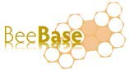

BeeBase is the NBU’s award winning website. It contains all the apicultural information relating to the statutory bee health programme in England and Wales. In June 2010, the information
for the Scottish inspections programme was also incorporated into BeeBase. The
website contains a wide range of beekeeping information, such as the activities of the NBU, the bee related legislation, pests and diseases information including their recognition and control, interactive maps, current research areas, publications, advisory leaflets (including this one) and key contacts. To access
this information visit the NBU website (www.nationalbeeunit.com). Many beekeepers find this website to be a very useful source of information and advice. In addition to the public pages of the BeeBase website, registered users can view their own apiary records, diagnostic histories and details.

Why is it so important to register on BeeBase?
As well as containing useful information on beekeeping, BeeBase is a vital tool in the control of bee disease and pests. Where statutory pests or diseases (for example, foulbrood) are confirmed, the NBU uses BeeBase to identify apiaries at risk in the local area and, as a result, target control measures effectively. By knowing where colonies are,
we can help you manage disease risks in your apiaries. Such risks include the incursion of serious exotic pest threats (for example Small hive beetle). The more beekeepers who are registered, the more rigorous our bee health surveillance is and, crucially, the better our chances of eliminating pests and diseases.

How to sign up to BeeBase
If you are not yet registered please visit the public pages of BeeBase where you can sign up online at: www.nationalbeeunit.com. Otherwise you can get in touch with the NBU office team who will be happy to help. You can email us
at: nbu@apaha.gsi.gov.uk or contact us by telephone on: +44 0300 3030094. By telling us who you are, you will be playing a very
important part in helping to maintain and sustain honey bees for the future.

How do I know that my details will be secure?
All of the information that you provide for the purposes of registration on BeeBase is
covered by the Public Service Guarantee on Data Handling (see Confidentiality page of BeeBase). In addition, all data will be handled according to rules stated in the Data Protection Act, 1998. All levels of access to BeeBase are protected in the same way as on-line banking. Your personal access is password protected. When you first register you are allocated a temporary password, which is valid for your
first visit only. You will then be prompted to set your own password. You need to ensure that your own password remains confidential. You will also be allocated a personal ID Number, which relates solely to you. As a personally registered beekeeper, once you have received an inspection visit, you can check your own record on BeeBase. If you wish, you can make use of the apiary records system to record your apiary visits. Your SBI, RBI, NBI and NBU staff at APHA will have access to your records, but no Inspector or NBU staff member will ever disclose to others that you have been inspected
or any details about your bees or beekeeping without your consent. Although BeeBase includes public pages containing information such as disease, colony losses, leaflets, useful links and much more general information,
the public has no access to your or other beekeepers’ details.

Beekeeping Associations
In many areas, Beekeeping Associations operate disease training schemes and provide practical advice and advisory leaflets to members on bee disease recognition and management. Contact your local Beekeeping Association or bee health advisor for details (England – www.bbka.org.uk;
Wales – www.wbka.com and the Bee Farmers Association – http://beefarmers.co.uk/).

Introduction to Varroa

This section gives a simple introduction to the Varroa mite, its presence in the UK, and its management by beekeepers. The concepts you will find below are explained in more detail later in the leaflet.

What is Varroa?
Varroa destructor (Acari: Varroidae), formerly known as Varroa jacobsoni, is a species of mite – an animal group more closely related to
spiders and ticks than to insects. Varroa lives as an external parasite of honey bees. Originally confined to the Asian honey bee, Apis cerana,
it has spread in recent decades to the Western honey bee, Apis mellifera.

Why is it a problem?
Unlike Apis cerana, our honey bee has few natural defences against Varroa. The mites feed on brood, weakening them and spreading harmful pathogens such as bee viruses. Infested colonies eventually die out unless control measures are regularly applied.

Where is it found?
Varroa has spread through movement of infested bees far outside its natural range in Asia. It is now present on all continents except mainland Australasia. First found in the UK
in 1992, it has since spread to affect nearly all apiaries in the UK, though it has not been
confirmed in the Isles of Scilly or the Isle of Man and some parts of Scotland.

How did it get to the UK?
We do not know for certain how Varroa reached the UK. Inadvertent movement of infested
bees in imported goods is thought to be the most likely cause, although deliberate illegal importation of bees from infested countries is also a possible route.

Do I have to report the presence of Varroa in my colonies?
Varroa has been removed from the list of notifiable diseases so beekeepers are no longer obliged to report its presence in their colonies.

Can Varroa be eradicated or controlled?
Varroa cannot be completely eradicated but beekeepers can successfully keep productive bees despite the presence of the mite. Varroa can be controlled by monitoring the infestation in colonies and the use of appropriate control
methods to keep mite numbers below levels that are harmful.

How do I know how badly infested my colonies are?
The signs of infestation may not be obvious until your colonies are heavily infested – by which stage they are at great risk. However, there are several methods that can be used to detect the mites and estimate their numbers at a much earlier stage. These include counting dead
mites that collect on the hive floor, and counting mites inside sealed brood cells. These methods help you plan the control methods to use.

What control methods are available?
Control methods can be divided into two groups: management methods (‘biotechnical
methods’) and medicinal controls (‘varroacides’).
In practice, the best controls result from using a combination of methods at different times of the year depending on the level of infestation. This is commonly known as ‘Integrated Pest Management’ or ‘IPM’.

Varroa Biology

What are ‘pyrethroid resistant’ mites?
In recent years Varroa mites in many areas have developed resistance to pyrethroids – the active ingredients in the varroacides which, until recently, were most commonly used to control
them. As pyrethroids do not kill such mites other treatments need to be used instead. Resistance has spread widely throughout many parts of the UK – posing a new and significant challenge
for beekeepers. This problem has not, however, yet reached the whole of the UK, and in these areas they will still work very well. In some areas where pyrethroids have not been used for several years, mites may become susceptable again. In such areas pyrethroids must not be used repetitively, but occasionally, as part of an IPM programme.

The onset of mite resistance to other control substances now being used is very likely.

Feeding
Varroa can feed and survive on both adult bees and their brood. The mites feed on their host’s haemolymph (blood) through punctures made in the body wall with their sharp mouthparts.

Reproduction
The entire life cycle of Varroa destructor mites occurs within the bee hive. It consists of a phoretic stage (transport phase) as a parasite on adult bees and a reproductive stage inside the sealed brood cells. To breed, a gravid (egg- carrying) female mite enters an occupied brood cell just before the cell is capped over, where she remains in the brood food under the honey bee larva until the cell is sealed. During this time she breathes through a respiritary organ, common in mites, called the peritreme, until
after cell capping when the bee larva consumes the rest of the food. Varroa prefer to breed in drone brood (10-12 times more frequently), but will also use worker brood. About four hours after capping the female mite starts feeding on the immature bee, establishing a feeding site on this host from which her offspring can feed as they develop. If you look carefully, you will see spots of white faeces or feeding Varroa around this site, usually towards the hind end of the
developing pupa. These white spots will also be seen on the cell walls. About 60-70 hours after capping the female lays the first of her eggs. For further details please see the life-cycle diagram.

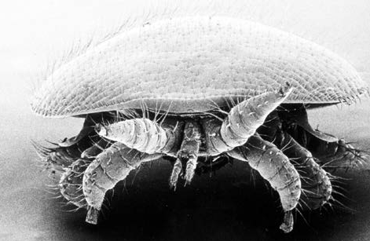
Figure 1: Close up of adult female Varroa mite

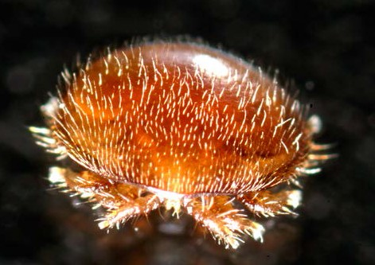
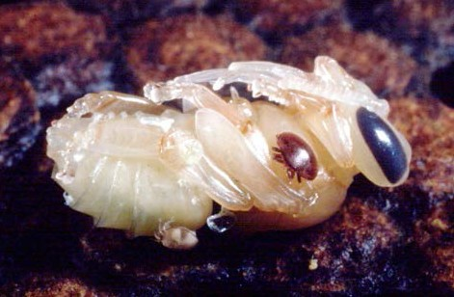
Figure 2: High magnification electron micrograph of adult female Varroa mite

Figure 3: Varroa mites in different stages of development on a pupal worker bee

Figure 4: Immature mites on pupa

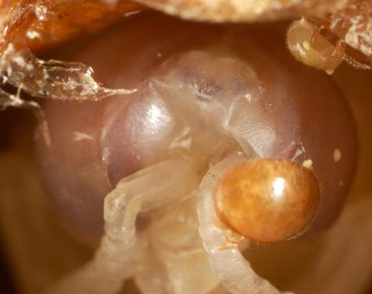
Developing mites pass through two juvenile stages, known as the protonymph and deutonymph, before becoming adults. Development time from egg to adult for males is 5-6 days and for females 6-7 days. Mating
between male and female mite offspring occurs within the cell. Each female lays 5-6 eggs, the first being a male followed by 4-5 female eggs laid at regular 30-hour intervals. The first egg
to hatch is the male, then the oldest daughter moults to adulthood 20 hours later. By laying only one male egg, Varroa increases the number of females that can reproduce at the next generation. Since the males do not survive outside the cell, females must be fertilised before the bee emerges from the cell, otherwise they remain sterile.

The duration of each reproductive cycle is limited by the development time of the bee, so not all mites reach maturity and mate by the time the bee emerges from the cell. Males and any remaining immature females die, unable
to survive outside the sealed cell. With heavy infestation, two or more female mites may enter the same cell to breed, and female mites may produce more than one generation.

Mature female mites leave the cell when the host bee emerges. Some of these may
produce a second or third generation of mites by entering new brood cells. The success rate of reproduction (new mature female mites) in worker brood is about 1.7-2 but increases to between 2 and 3 in drone brood due to the longer development period. The development and status of a colony affects mite population growth and, depending on circumstances, mite numbers will increase between 12 and 800 fold over a season. This means that mite levels can resurge rapidly after treatment.

Life-span
The life expectancy of Varroa mites depends on the presence of brood and will vary from 27 days to about 5 months. During the summer Varroa mites live for about 2-3 months during which time, providing brood is available,
they can complete 3-4 breeding cycles. In winter, when brood rearing is restricted, mites over-winter solely on the bodies of the adult bees within the cluster, until brood rearing commences the following spring.

How Varroa spreads
Varroa mites are mobile and can readily move between bees and within the hive. However,
to travel between colonies they depend upon adult bees for transport – through the natural processes of drifting, robbing, and swarming.

In this way Varroa can spread slowly over long distances. However, the movement of infested colonies by beekeepers is the principle means of spread over long distances.

6 1

The duration of each reproductive cycle is limited by the development time of the bee, so more mites are produced in drone brood than in worker brood. Not all females reach maturity and mate by the time the bee emerges from the cell. Mature female mites leave the cell with the emerging bee. Immature females and the males do not survive outside the cell.

Varroa feed on the haemolymph (blood) of the bees by making punctures through the body wall with their sharp mouthparts. Mites have a preference for nurse bees. During the summer mites live for 2-3 months and readily transfer from bee to bee and brood cell to brood cell. In winter mites live much longer and over-winter on adult bees within the cluster until re-entering the brood the following spring. Feeding of the mites can weaken and damage bees and brood.

The life cycle of the Varroa mite (Varroa destructor) in the European honey bee Apis mellifera

2
Adult female

5

Development of the mite is through two juvenile stages: the protonymph and deutonymph before
Young adult 1 Adult male
7 2

3 Egg
6
5 4
To breed, an adult female mite enters a brood cell just prior to capping, where she remains in the brood food under the larva until the cell is sealed. Mites prefer

becoming an adult. Time from egg to adult for males is 5-6 days and for females 6-7 days.
Deutonymph

Protonymph
Larva
drone brood but will also
breed in worker brood.

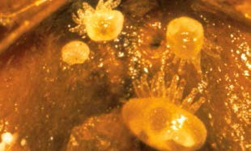
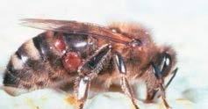
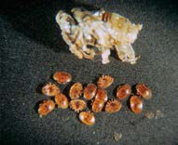
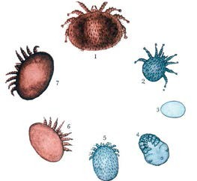
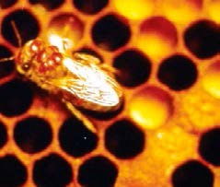
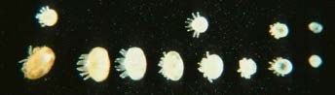
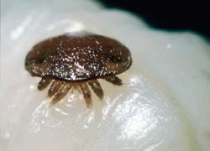
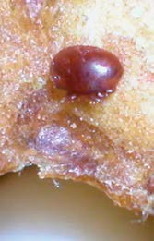

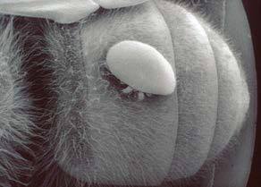
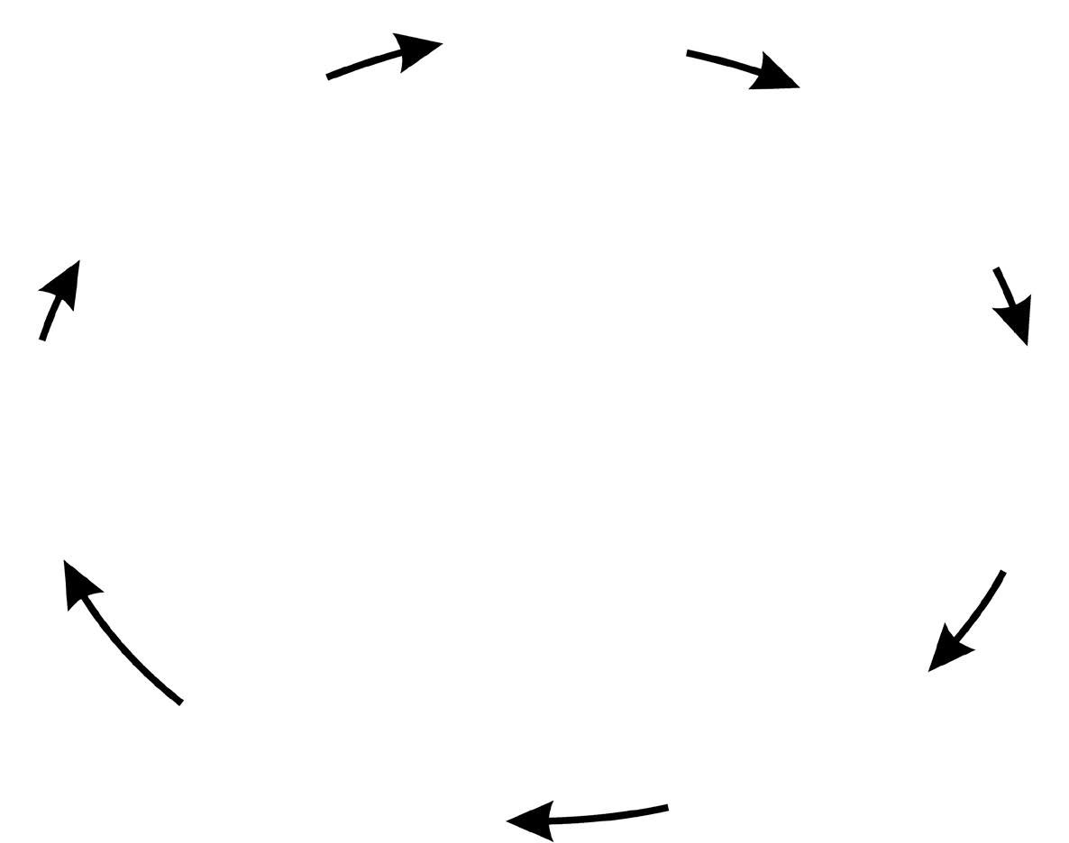
Introduction to Varroa 8

4

Each female mite lays 5-6 eggs, the first always being a male egg followed by 4-5 female eggs laid at regular 30 hour intervals. The male hatches first followed by the females. The male mite then mates with the female offspring within the cell.

Wolfgang Ritter CVUA Freiburg

The entire life cycle takes place within the bee hive. It consists of a phoretic stage (transport phase) as a parasite on adult bees and a reproductive stage inside sealed brood cells.

3

Four hours after capping the female mite begins to feed off the developing bee, and establishes a feeding site for her offspring. 60-70 hours after capping the female lays the first of her eggs.

Harmful effects of Varroa

Effects on individual bees
Individual bees infested with Varroa during their Some brood infested by Varroa may die, usually development usually survive to emergence but at the pupal stage of development, and remain may show signs of physical or physiological in the cell until removed by adult bees.
damage as adults. These include shorter
lifespan, reduced weight, shrunken and deformed wings and reduced natural resistance to infections.

Figure 5: Commom symptoms of heavy Varroa
infestation – a worker bee with deformed wings
Figure 6: Varroa damage: normal bee in the middle, deformed bee on the right

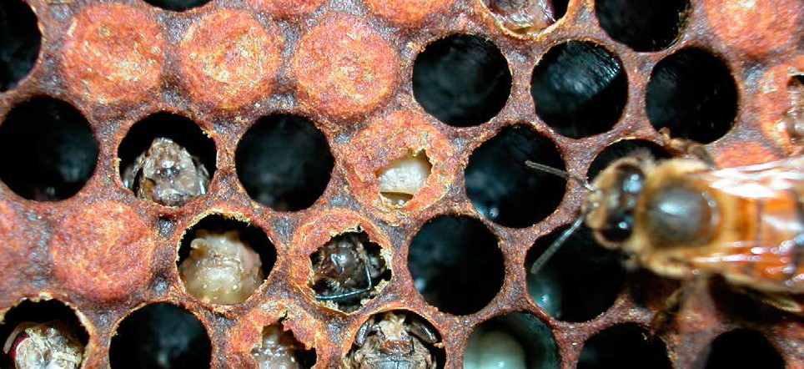

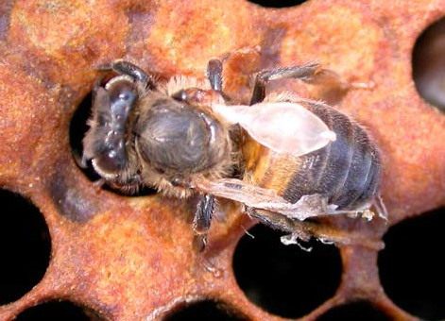
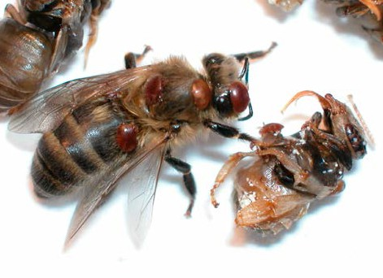
Figure 7: Damaged brood in a comb from a collapsing colony

Varroa, viruses and other pathogens
There are many bee viruses that are naturally present at a low level in the bee population without normally causing significant harm. When Varroa feeds, as well as taking essential nourishment away from the developing bee, the mite, acting as the vector, can aid virus spread
so that in heavily infested colonies they become much more widespread and potentially harmful by reducing the bees’ lifespan. Varroa may also worsen the harmful effects of other common bee diseases such as Acarapisosis (caused by the tracheal mite, Acarapis woodi).

Effects on colonies
Small numbers of Varroa mites infesting a colony will usually cause no obvious harm. However, as the level of infestation rises, the risk of harmful effects also rises. In poorly managed colonies where infestation is allowed
to increase, signs of damage to the entire colony start to become evident. Severe infestation slows the replacement of old adult bees with healthy young bees and may lead to the rapid
spread of harmful bee viruses in the colony. At this stage, the normal processes of foraging, brood rearing and colony defence diminish and the colony’s entire social organisation begins
to deteriorate – a process known as colony collapse.

Colony collapse is usually very rapid (taking only a few weeks) and may affect even strong colonies that have shown no outward signs of damage. However, a closer look would reveal many mites on adult bees (with deformities) and
heavily infested sealed drone and worker brood, often with many mites per cell.

Colony collapse can occur at any time of the year but in the UK happens most often in August and September. However, spring colony collapse, which in turn leads to mite invasion of neighbouring colonies, can be quite common
in March, April and sometimes into May.
These mites add to Varroa populations already present, which means that colony collapse can occur earlier than anticipated i.e. before the
end of the summer. It is important to check mite levels in spring to verify whether invasion has occurred.

Figure 8: Electron micrograph of particles of Acute Bee Paralysis Virus (ABPV)
Figure 9: Electron micrograph of the mouth parts of a Varroa mite

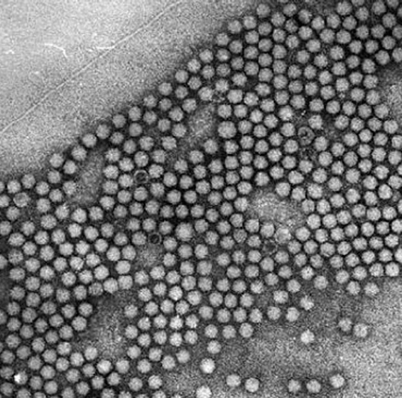
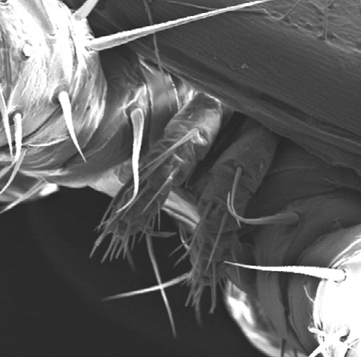
Photo courtesy of Brenda Ball, Rothamstead Research.

The signs of colony collapse

A sudden decrease in the adult bee population, usually with few dead adult bees present. Bees with deformed wings and abdomens.
Numerous Varroa mites on remaining bees, on worker and drone pupae, and on the hive floor.

Various abnormalities of the brood (e.g. bald brood, poor brood pattern, patches of neglected and dead ‘emerging’ brood often discoloured brown and partly removed by the bees).

Caution: make sure that these signs are not caused by foulbrood infection (see APHA’s leaflet ‘Foulbrood disease of honey bees and other common brood disorders’)

Figure 10: Damaged brood – signs of severe infestation, also known as ‘bee parasitic mite syndrome’

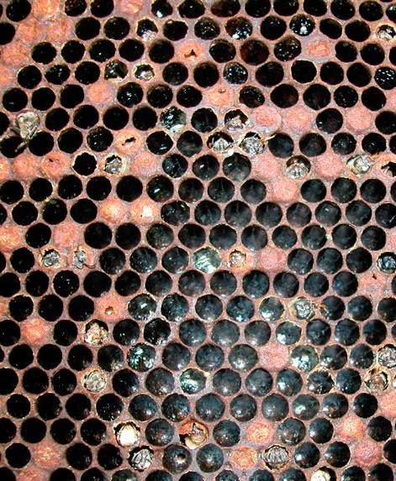
Harmful mite population threshold
There is no clear harmful threshold beyond which a Varroa population suddenly causes harm. A mite population that causes no obvious damage to one colony may prove very damaging to another. This can be due, in part, to differences in the levels and types of bee viruses and other pathogens present in the
colonies and the bees’ natural ability to tolerate
Varroa, as well as environmental factors.
However, researchers agree that in the UK it is wise to aim to keep the Varroa population below 1000 mites/colony; above this level the risk of damage from the mites, associated
pathogens and the effect of feeding on the bees can quickly become very significant. In Europe and parts of the United States, higher threshold levels of around 3000-4000 mites are generally used.

Mite invasion pressure
The spread of mites between colonies, by adult bees plays a key role in the mite population build-up. It can occur at any time of the year when bees are active. In areas of high colony density with heavily infested colonies, the rate of mite invasion can be extremely high, and populations may build up to damaging levels in a short time – sometimes in a matter of a few weeks or months.

Varroa population increase
Varroa populations in infested colonies increase naturally through two processes – the reproduction of mites in brood cells, and the influx of new mites into the colony through invasion.

Figures 11 to 13 illustrate these two processes. They are based on the assumption that mite populations double through mite reproduction approximately every four weeks – although
in reality the situation is more complicated as many factors (such as the amounts of worker and drone brood present) influence the rate of mite reproduction.

Figure 11 illustrates the increase in the mite population for colonies infested with differing numbers of mites at the start of the season (without any mite invasion from outside). During the 180 days shown, mite populations build up steadily. Where only very few (e.g. 10) mites are initially present the mite population remains well below the harmful threshold of 1000 mites for the entire period shown. However, in colonies starting with larger numbers of Varroa (100 or 200 mites), build up to harmful levels much faster. It is essential to ensure mite populations are as low as possible at the beginning of the active rearing season.

Figure 11: Effect of initial mite numbers on subsequent population growth

1,400

1,200

1,000
Number of Varroa Mites

800

600

400

200
10 Mites

100 Mites

200 Mites

0
0 10 20 30 40 50 60 70 80 90 100 110 120

Days

130 140 150 160 170 180

Figure 12 illustrates the effect of mite invasion. Where small numbers of mites are present at the start of the season, and no mite invasion occurs, the mite population remains below 1000 during the whole period shown. However, mite invasion early in the season causes the mite population to reach harmful levels much more quickly – depending on how many mites invade the colony.

Figure 12: Effect of mite invasion on subsequent mite population growth

1,400

1,200

1,000
Number of Varroa Mites

800

600

400

200

0 Mites

100 Mites

250 Mites

Invasion occurs

0
0 10 20 30 40 50 60 70 80 90 100 110 120

Days

130 140 150 160 170 180

Figure 13 shows the recovery in the mite population that occurs following treatment (for example with a varroacide). The fall in the mite population when treatment is applied depends on the treatment’s efficacy. When a very effective treatment is applied the mite population takes much longer to return to a harmful level than it does when less effective treatments are used. Understanding these principles is essential if you are to successfully use the methods of Varroa monitoring and control described later in this leaflet.

Figure 13: Effect of treatment efficacy on subsequent mite population growth

1,400
Varroacide Applied

1,200

1,000
Number of Varroa Mites

99%
90%
80%

800

600

400

200

0
0 10 20

30 40 50 60

70 80

90

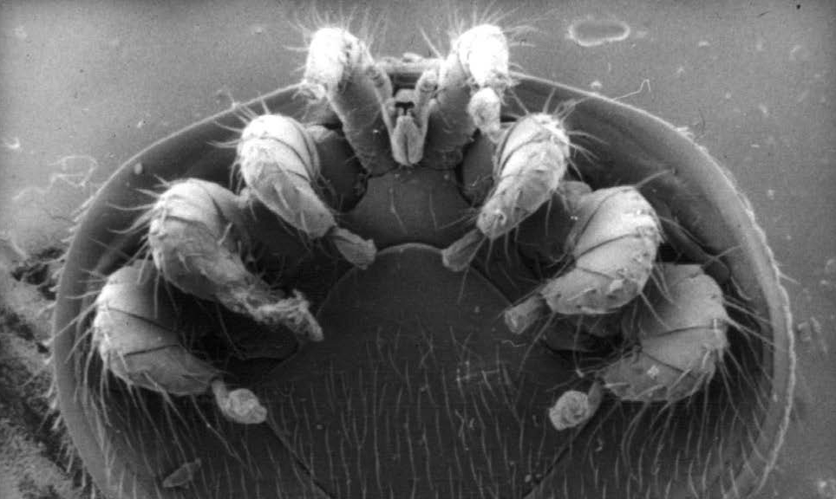
Days

100

110

120

130

140 150 160 170 180

Figure 14: Electron micrograph of a Varroa mite showing mouth parts, legs and ventral surface

How to recognise and monitor Varroa

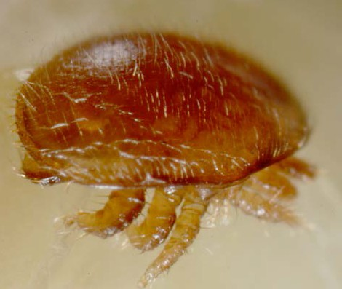
Varroa management is an essential part of contemporary beekeeping. All beekeepers need to make sure that they are able to recognise Varroa mites in their hive, and have one or more methods at their disposal for estimating how serious the infestation is.

Figure 15: Close up of adult female Varroa mite
Recognising Varroa
Female Varroa mites are easily recognised by their flat, reddish-brown oval bodies (1.6 x 1.1mm). Male Varroa mites exist only in brood cells, and are smaller and pale in
colour. Immature female mites are also found inside cells, and are paler than their adult counterparts.

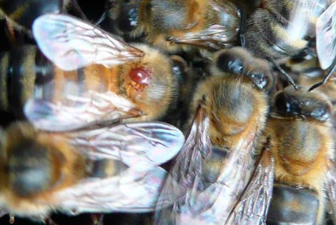
Since Varroa mites are very small, if you wear glasses for reading, you will probably need to wear them to see Varroa. Some beekeepers find a hand lens helpful too.

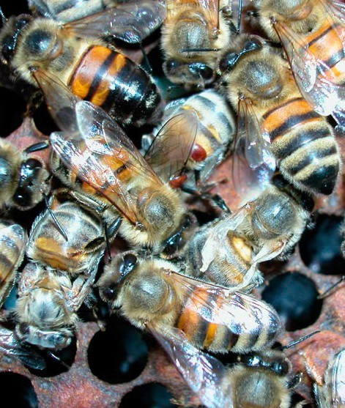
Figure 17: Braula coeca

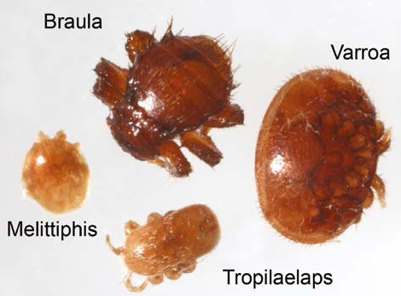
Figure 16: Varroa mites visible on the wing and abdomen of the worker bee in the middle of the picture

Figure 18: Braula coeca compared to Varroa, Tropilaelaps and Melittiphis

The bee-louse, Braula coeca (a wingless fly that lives harmlessly on adult bees (Figure 17)) may be confused with Varroa). It can be
distinguished from Varroa by its more rounded shape and its six legs, which are readily visible on both sides of its body. Two other mites that beekeepers need to be able to distinguish
are Tropilaelaps spp. and Melittiphis alvearius (Figure 18). Tropilaelaps is a serious exotic pest of honey bees and is notifiable (please see APHA’s leaflet Tropilaelaps: parasitic mites of honey bees). Melittiphis mites are predatory mites, preying on scavenger mites that occur
in bee hives. They do not harm honey bees or their brood.

Monitoring Varroa
You must learn to regularly estimate the level of infestation throughout each season. Infestation will build up more quickly in some years than in others and more quickly in some apiaries than others. A control programme that was effective one year will not always be effective in another.

Monitoring your colonies routinely using an open mesh floor (OMF) and a sticky insert tray coated with Vaseline will tell you how mite infestation is developing. You can then use this information to decide what and when control methods will be appropriate.

A range of monitoring methods is available (Table 1) to use – from the quick and approximate through to the complex and more accurate. You will have to decide which of these suit your own individual beekeeping practices.

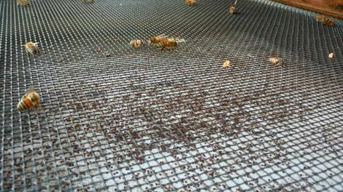
Figure 19: A screened floor suitable for monitoring natural mite fall. A typical floor will have 3mm metal mesh and a mite catching drawer/tray underneath

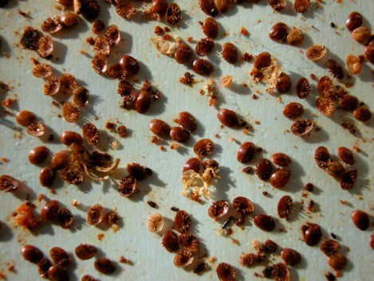
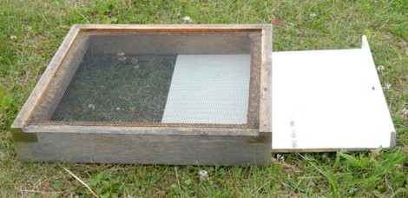
Figure 20: Varroa floor with insert covered in hive debris

Figure 21: Hive floor debris containing mites

Monitoring tips

How often should I monitor?

Ideally, you should aim to monitor at least four times each season: early spring, after the spring honey flow, at the time of honey harvest, and late autumn. If you think significant mite invasion is taking place then the frequency with which you monitor should be increased.

How many colonies should I monitor?

Mite levels vary significantly between colonies so ideally you should monitor all of your colonies. However, this may be impractical for larger scale beekeepers who should instead monitor a representative proportion of colonies in each apiary. Make sure you include some of the strongest colonies as these often have the highest mite populations.

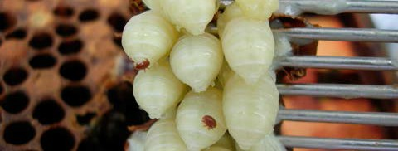
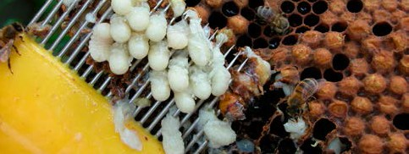
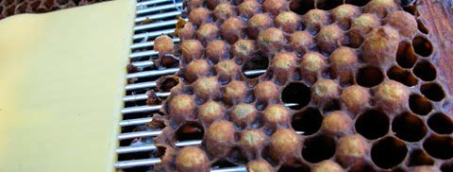
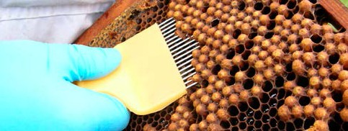
How to monitor colonies for Varroa

Table 1: Some commonly used Varroa monitoring methods

Method: Monitoring natural mite mortality (‘mite drop’) Pros and Cons
- Maintain the colony on a Varroa-floor with a sampling drawer/ ü sensitive method capable tray underneath. of detecting very few
- Remember to remove debris from the drawer/tray regularly mites
during the summer to prevent severe wax moth infestation. ü can give a good idea of
- At intervals examine the floor debris and count the number of infestation level
Varroa mites. Convert this to a daily ‘mite drop’ figure by dividing
by the number of days since the last measurement. ü colony is not disturbed
- If there is a lot of debris (e.g. after winter) mites will be very û needs additional difficult to find. Mix the debris with methylated spirit in a large equipment
container. Most dead mites will float to the surface whereas wax û monitoring takes several and propolis particles will sink. days
- Research work in the UK and overseas has shown a natural û encourages wax moths if mite drop in a colony is related to the size of the Varroa debris accumulates population.
Method: Drone brood uncapping Pros and Cons
- Select an area of sealed drone brood at an advanced stage of ü quick and easy to use development (pink-eyed) as this is least likely to disintegrate
when removed. ü can be used during
- Slide the prongs of a honey uncapping-fork under the domed routine colony inspections
cappings, parallel to the comb surface, and lift out the drone ü gives instant indication of pupae in a single scooping motion (see Figures 22-25 below infestation level
and Figure 55).
- Varroa mites are easily seen against the pale drone bodies. û unlikely to detect a very Repeat until at least 100 cells have been examined. light infestation
- Estimate the proportion of pupae that have Varroa mites on û results are approximate them.
- Very roughly, if more then 5-10% of drone pupae are infested, then the infestation is serious and the colony collapse may occur before the end of the season.

Figures 22 to 25: Drone brood uncapping

How to control Varroa infestation

The aim of Varroa control
The fundamental aim of Varroa control is to keep the mite population below the level
where harm is likely, (known as the economic injury level), therefore maintaining healthy colonies of bees for the production of honey and other hive products, and for pollination.
It is not necessary to kill every single mite for effective control and it is not usually desirable to attempt this. However, the more mites that are left behind, the quicker they will build up to harmful levels again (see Figure 11). With 80% treatment efficacy the danger level (of 1,000 mites) is reached again in only 65 days; with higher efficacy of 90% this takes 100 days;
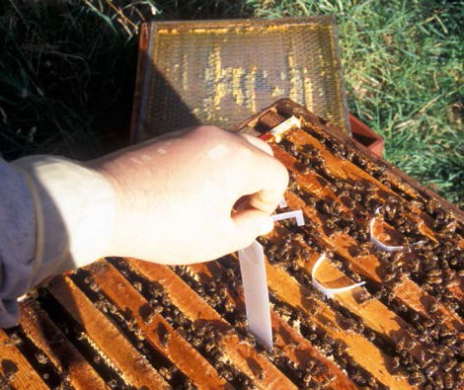
with 99% efficacy, population growth is so slow that assessments can be made the following season.

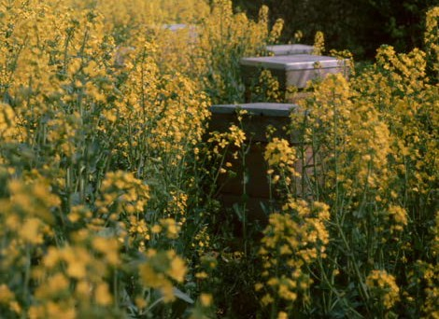
Figure 26: Beekeeper putting in varroacide medicament strips
Types of control
Current control methods used by beekeepers against Varroa can be divided into two main categories, each of which has pros and
cons. (Table 2): ‘Varroacides’ – The use of medicines (containing chemicals) to kill mites (or otherwise reduce their numbers). These are applied in feed, directly on to adult bees, as fumigants, contact strips or by evaporation.
These may include authorised proprietary veterinary medicines and unauthorised generic substances. ‘Biotechnical Methods’ – The use of methods based on bee husbandry to reduce the mite population through physical means alone. Many of the most popular and effective methods involve trapping the mites in combs of brood, which are then removed and destroyed. Generally these methods are only suitable for use in spring and early summer. They reduce the need to use medicines and are of great benefit in areas with late honey flows (see IPM section).

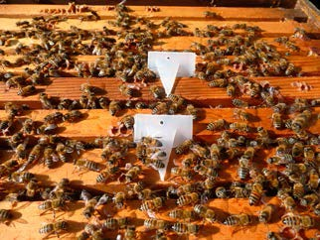
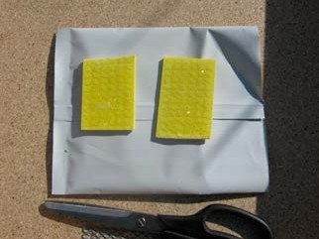
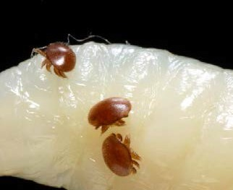
Figure 27: Oil seed rape, a major UK honey crop

Figures 28 to 30: Successful beekeeping depends on effective Varroa management

Using biotechnical controls

All biotechnical controls exploit the fact that mites reproduce in the bee brood. Unsealed brood can be used to trap and remove Varroa from the colony. If a bee colony is broodless and a frame of open brood is then added, the mites will enter the brood to reproduce (the brood acts
as a ‘sink’); so when capped over, the beekeeper can remove and destroy the comb along with
the enclosed mites. With this procedure removal of more than 90% of the Varroa population is commonly achieved.

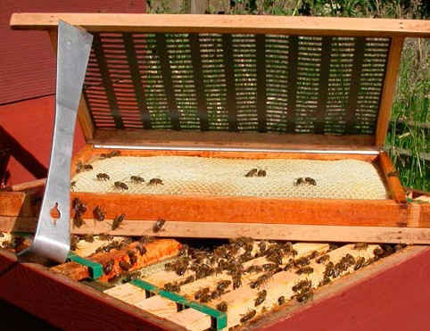
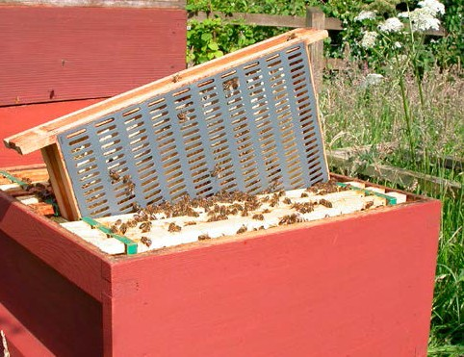
Biotechnical control methods allow beekeepers to control Varroa without the use of chemical varroacides. This makes them especially useful during the active season when supers are on
the hive and using a varroacide may not be appropriate. By using biotechnical methods, beekeepers can keep their use of chemical varroacides to an absolute minimum – or enable them to use varroacides that they may prefer
but which have relatively low efficacy.

Some sophisticated biotechnical methods such as ‘comb trapping’ (see Table 3 and Figures 31 – 33) can be extremely successful, with an efficacy similar to that of proprietary
varroacides. However, such methods tend to be relatively time consuming and complicated to use and are critically dependant on good timing, so are most suitable for experienced and small- scale beekeepers.

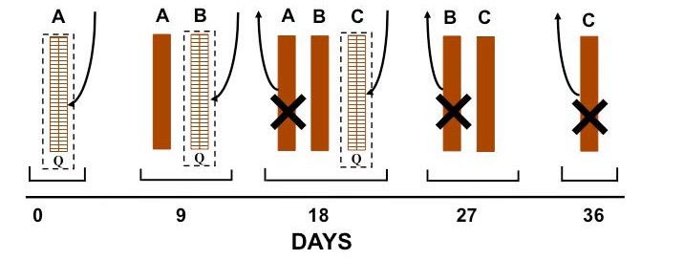
Figures 31 and 32: Comb trapping – an effective biotechnical control method

Figure 33: Comb trapping timetable. The queen (‘Q’) is caged for 9 days on three combs (‘A’, ‘B’ and ‘C’) in succession. They each remain in the colony for a further 9 days while Varroa mites enter the brood cells to breed. The combs containing mites ‘trapped’ in sealed brood are then removed

Other methods, such as ‘drone brood removal’ (see figures 34, 35 and Table 3) are much quicker and less complicated to use. Although less effective, they can play a valuable role in slowing mite population build-up, thus reducing the frequency that other control methods need
to be used.

One of the advantages of biotechnical controls is that their use can often be naturally combined with other beekeeping operations. For example, drone brood removal fits in well with routine
swarm control inspections. There are some very effective methods that combine swarm-control with Varroa control (see Table 3). Such methods are likely to grow in popularity as beekeepers become more familiar with them.

Despite these advantages, as a result of their nature, most biotechnical methods are only suitable for restricted periods of the year. Outside these periods they may be ineffective and harmful to the colony. As a general rule, in heavily infested apiaries biotechnical methods are unlikely to provide sufficient control of
Varroa if used alone and so will need to be used in conjunction with chemical varroacides.

Figure 34: Drone brood visible in lower parts of frame

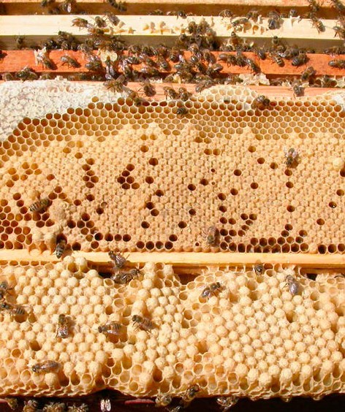
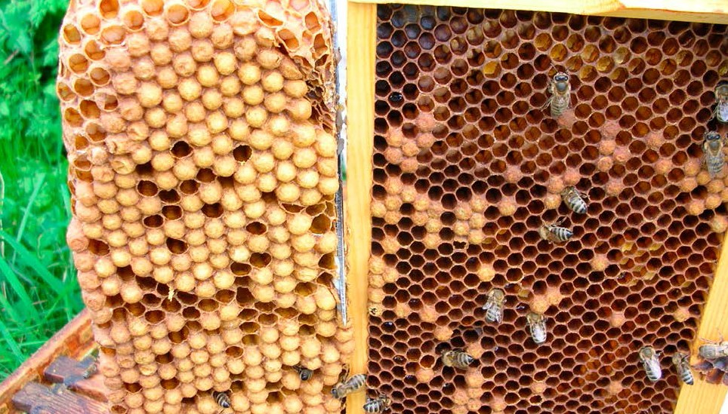

Figure 35: Drone brood removal – cut away the capped drone brood seen in left of image.

Table 2: Advantages and disadvantages of biotechnical methods and varroacides

 | Advantages | Disadvantages
Biotechnical methods | - Do not require the use of chemical varroacides  - Can be combined with summer management  - Inexpensive or free | û Can be time-consuming  û Some need a high level of beekeeping skill  û Generally not sufficient if used alone  û Misuse can harm colonies
Authorised varroacides | - Proven efficacy ü Proven safety ü Convenient to use | û Mites likely to develop resistance  û Residue problems in bee products if misused  û Can be expensive
Unauthorised varroacides (generic substances) | - Some can be very effective ü Usually relatively cheap ü Usually natural substances ü Many present low residue risk  - Some offer control options not currently provided by biotechnical or authorised varroacides | û Use not approved by law in most situations  û Efficacy may be low/variable  û Safety typically not proven: some present serious risks to bees and beekeeper  û Some present risk of residues in bee products

Figure 36: Diagram illustrating the control of Varroa using an ‘Artificial Swarm’

Start
Super

Super
‘Parent Colony’

New Drawn Comb or Foundation
>4 metres

Old Queen
‘Parent Colony’
Select One Open Queen Cell. Destroy Any Others

Feeder

‘Swarm Colony’

+9 Days
Super if needed Super

Maintain Swarm Prevention Feed if Needed
Cage Selected Queen Cell Destroy
Any Others

+21 Days
Transfer Two Frames of Open Brood (bait combs)

Completion
When Sealed Destroy Brood & Cull Virgin Queen

Unite & Re-Queen

Table 3: Some commonly used biotechnical methods

Method | How to use | Main features
Drone brood | 1. Place two shallow combs in the brood chamber in spring and | - easy to use
removal | allow the bees to build natural drone comb beneath them. A
(see Figures 34 | good time to put these in the colony is when the queen first | - quick
and 35) | begins to lay up drone brood. Place the combs into the colony  one at a time, and alternate at 9 day intervals (a run of alternating pairs of frames). Another option is to use an empty deep  frame fitted with a starter strip of foundation to avoid possible misshapen comb.  - When a drone comb is full of sealed drone brood (infested with  Varroa), cut it from the frame before it emerges and destroy it. Failure to do this will breed more mites. The frame can be re-used immediately.  - Repeat the process several times in the season for maximum effectiveness. | - no special apparatus required  - no varroacide used ü well tolerated by colony û useful, but limited  efficacy
Comb trapping | 1. Confine the queen to a worker comb ‘A’ using a purpose-made | - can be very effective
(see Figures 32 | comb-cage (available commercially).
and 33) | - After 9 days confine her to a new, empty comb ‘B’ and leave comb ‘A’ in the brood chamber to become infested with mites.  - After a further 9 days remove comb ‘A’ (now sealed). Confine the queen to a new comb ‘C’, leaving comb ‘B’ in the brood chamber.  - After 9 more days remove comb ‘B’. Release the queen (or  re-queen by introducing another queen) leaving comb ‘C’ in the brood chamber.  - After 9 more days, remove comb ‘C’. | - no varroacide used  - more bees recruited to foraging  û time-consuming  û requires good beekeeping skill  û can harm/weaken the colony if used without regard to time of season  (e.g. late summer)
Artificial swarm | 1. Move parent colony to one side of the original site, at least | - combines swarm control
(see Figure 36) | 4 metres away.  - Place a second hive containing newly drawn combs and the queen (alone) on the original site to house the artificial swarm. Foragers will return to this hive creating the artificial swarm.  - After 9 days remove all but one queen cell from the parent colony. The cell can be protected in a queen cell nursery cage which prevents the virgin queen from leaving the hive to mate, but allows worker bees access to care for her.  - After 3 weeks all brood in the parent colony will have hatched.  Transfer two bait combs of unsealed brood from the artificial swarm to the parent colony, and when they are capped, remove and destroy them. At this stage, cull the virgin and introduce a new queen to the parent colony.  - The old queen in the swarm can later be removed and the two colonies reunited. | with Varroa control  - removes a high proportion of Varroa mites present  - new queen introduced  û only suitable for use in the swarming season  û it may be necessary to take precautions to  prevent absconding in the artificial swarm – such as placing a queen excluder below the brood chamber for a few days
Open mesh | 1. Fit a mesh Varroa-monitoring floor (without a collection tray) to | - open mesh floor
floors (see  Figure 19) | the hive.  - Many of the mites falling from the colony are alive. The mesh floor allows these to drop out of the hive rather than returning to the colony.  - A lower proportion of mites is considered to enter the brood to reproduce.  - Used in conjunction with other control methods this method helps keep mite numbers down. | removes some live  Varroa  - no debris on floor to encourage wax moths  - improves hive ventilation  - can use collection tray to measure mite drop when required  û not sufficient if used alone

Using varroacides

‘Hard’ versus ‘Soft’ varroacides
For most beekeepers, varroacides are a key element of their Varroa control programme. Some beekeepers like to distinguish between varroacides by calling them ‘hard’ varroacides (synthesised proprietary chemicals) or ‘soft’ varroacides (chemicals that may be synthesised
but which are also found in nature e.g. formic acid, essential oils). This is misleading. Many so-called ‘soft’ chemicals are quite harmful in concentration. A better distinction is between authorised varroacides (veterinary medicinal products fully tested for efficacy and safety) and unauthorised alternative varroacides (use of natural, generic substances in non-approved applications).

Authorised varroacides
Under EU law, veterinary medicinal products must be authorised in the Member State concerned before they may be marketed
or administered to honey bee colonies. Authorisation requires a thorough scientific assessment of data to show that the product meets statutory levels of quality, efficacy and safety (to the user, bees, consumers of bee products and the environment). In the UK, the Veterinary Medicines Directorate (VMD), an agency under Defra, has responsibility for the authorisation and control of veterinary medicines. Currently authorised varroacides are available from equipment suppliers but this may change to require certification by suitably qualified persons (SQPs). See VMD’s Bee information on their website (www.gov.uk/government/organisations/ veterinary-medicines-directorate).

The veterinary medicines legislation does not allow a veterinary medicinal product authorised in one Member State to be automatically authorised in another. This is because there may be differences in beekeeping techniques, disease patterns, or environmental factors that may affect its safe and effective use. However, under the principle of ‘mutual recognition’
a simplified procedure can apply to the authorisation of a varroacide that already has a marketing authorisation in another Member State. In order to obtain an authorisation an application must be submitted in accordance with the requirements in the legislation.

Use of non-approved generic substances
In many European countries, including the UK, some beekeepers have used generic naturally occurring substances including organic acids (such as formic acid, lactic acid and oxalic acid) and essential oils (such as thymol) as part of their Varroa control programme.

In most cases, no formal testing of efficacy or safety of these substances has taken place, and therefore there is a danger that they are ineffective, harmful to bees, the environment or the user, or leave harmful or otherwise undesirable residues in bee products.
Beekeepers contemplating their use need to be aware that personal protective clothing (such as gloves, face and eye protection, and respiratory protection) may be necessary. Beekeepers should also be aware that they are liable to be prosecuted should the routine sampling and testing of products for residues find positive results.

The ‘Cascade Principle’
The legal position relating to the use of such generic substances is complex. Under the existing legislation, it is not legal to market or to administer a Veterinary Medicinal Product (VMP) that is not authorised by the VMD.
However, exceptions exist under the ‘prescribing Cascade’. Where no VMP is authorised for a condition in a particular species, this allows a veterinary surgeon acting under the cascade
to use a product authorised in another Member State (subject to certain conditions and restrictions), or to use an extemporaneous preparation provided the active ingredient has a Maximum Residue Limit (MRL) defined. As lactic, formic, and oxalic acids all are listed as
not requiring an MRL (in Council Regulation No 470/2009) they will be able to be used under prescription by a veterinarian in accordance with the prescribing cascade provisions.

Special Import Certificate
In order to use a veterinary product under the Cascade, beekeepers must apply for a Special Import Certificate (SIC). The veterinary medicine must then be used strictly according to the

forms of its EU authorisation and the withdrawl period adhered to. Information about products available under the SIC can be found at: www. gov.uk/guidance/bee-medicines-availability-in- the-uk

Further information on administration controls and the prescribing cascade is available on the VMD website. Information regarding advice and a list of veterinarians who are able to provide beekeepers with Varroa medicines under the prescribing cascade is available from the VMD website.

Misuse of agrochemicals
The active ingredients of many proprietary varroacides were originally developed to control pests of crops or livestock. When marketed as varroacides, they are specifically formulated
for safe and effective use with bees. Under the authorisation process the specific formulation, along with the container and packaging (which may affect chemical stability) and the labelling, is assessed for use in accordance with the manufacturer’s instructions. Home-made concoctions made with the active ingredients of these (often available as agrochemicals) should never be used. These pose serious risks to the user and to bees, and can leave
harmful residues in bee products. Furthermore, misuse of this sort has been attributed to
rapid development of resistance in countries overseas.

Chemical residues in bee products
Any chemical substance applied to honey bee colonies has the potential to leave residues in bee products. The risk of these being harmful can be minimised by the following rules:
Use authorised products with a proven track record in preference to alternatives that may lack reliable residue data
Always follow the label directions supplied with all authorised products
Never treat immediately before or during a honey-flow, or while supers are on the hive, unless the label directions of an authorised product specifically permit this.

Residues monitoring programme
In the UK, the VMD carries out a National Surveillance Scheme to protect consumers

Figure 37: Oxalic acid treatment applied with syringe and backpack

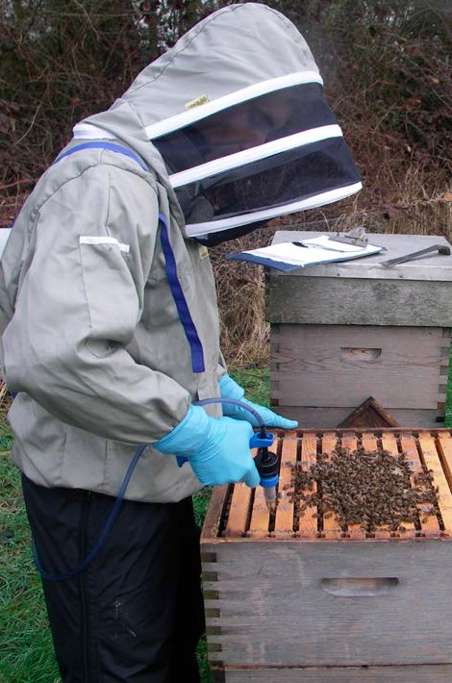
against potentially harmful residues of veterinary medicines and other contaminants in food.

Samples for the honey monitoring programme are collected on behalf of the VMD by APHA Bee Inspectors during their apiary visits, and these are analysed for a range of possible contaminants including residues of varroacides. Individual results are given to the beekeepers concerned and the overall findings of the programme are published annually by the VMD, within the Marketing Authorisation Veterinary Information Service (MAVIS) reports and through the Veterinary Residues Committee (VRC)

Beekeepers should be aware that they are liable to prosecution should the routine sampling and testing of products for residues find positive results. It is a legal requirement to keep
accurate records of what treatments you give your bees, including all relevant details such as dates, dose, product name and batch number.
In the event of a later problem these records are your proof that you acted properly.

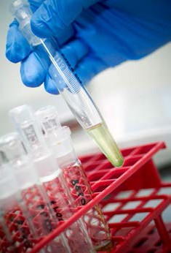
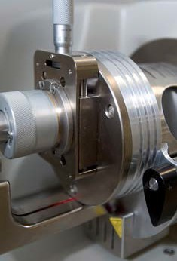
Figure 38: ‘Bagged and securely tagged’ honey samples, collected as part of the statutory residue monitoring programme
Figures 39 and 40: Testing honey samples for residue analysis

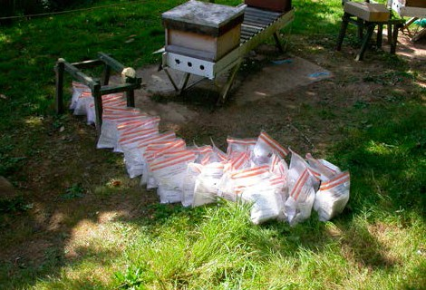
Varroacides and your responsibilities under the law

Use UK authorised varroacides and follow strictly the manufacturer’s instructions for their use. By doing so, you can be quite sure that you are remaining within the law.

The rules for use of generic substances in bee colonies are complex and changing. Make sure that you have reliable and up to date information on the legal status of any other treatment you may be considering. Details regarding authorised products are available on the VMD website at: www.gov.uk/guidance/bee-medicines-availability-in-the-uk

Keep accurate records of what treatments you give your bees, including all relevant details such as dates, dose, product name and batch number. In the event of a later problem, this legal requirement is your proof that you acted properly.

You may be requested to provide a sample of your honey for residue analysis as part of the VMD’s residue monitoring programme.

Table 4: Some varroacides commonly used by beekeepers in the European Union
25 Using varroacides

Name | Authorised | Active ingredient (a.i) | How applied | Method of spread | When normally applied | Significant features
Apiguard®  (Vita Europe) | UK | Thymol (terpene) | Slow release gel matrix (25% a.i.); two 50g pack treatments with 10–15 day interval. | Evaporation, contact, ingestion. | Spring or late summer after honey harvest for 4–6 weeks. | >90-95% efficacy with optimum conditions; depends on temperature and bee activity. When using ensure  Varroa mesh floors are closed and vents in crownboards are covered.
Apilife-VAR®  (LAIF) | UK | Thymol, eucalyptol, menthol, camphor | Vermiculite carrier matrix. | Evaporation. | Autumn for 3–4 weeks. | Temperature dependent; high efficacy up to 70–90% but some variability; easy to apply.
Thymovar  (Biovet) | UK | Cellulose sponge strip or “wafer” containing 15g Thymol | Wafers placed directly on top bars of brood nests. For use within an IPM system, e.g.combined with Oxalic acid treatment in winter broodless period. | Evaporation. | Late summer after honey harvest. Two successive treatments lasting 3–4 weeks. | Variable efficacy, best results at daytime temps between 20–25°C. Do not use above 30°C. Not for use during a nectar flow. Avoid contact with skin and eyes.  Overdosing may cause mortality of bees and larvae and make the colony “irritable”.
Mite Away Quick Strips (MAQS) | UK | Formic acid | Place two pads on the top bars of the hive, staggering them so they lay flat across the full width of the hive body. The honey bee cluster must cover a minimum of 6 brood frames. Ensure hive entrance is fully open. | Evaporation. | Spring to autumn even when there is a honey flow. Outside daytime temperature highs should be from 10–29.5°C  on day of application. Application should last 7 days. | If temperatures exceed 29.5°C excessive brood and queen loss may occur. Highly effective with no withdrawl period. Kills mites in sealed brood.
Bayvarol®  (Bayer) | UK | Flumethrin (synthetic pyrethroid) | Plastic strips hung between brood combs. | Contact. | Autumn or early spring for 6 weeks. | Highly effective >95%; can be used during honey flow; too similar to Apistan to use with it as alternating treatment. In most places in UK pyrethroid resistant mites are confirmed.
Apistan®  (Vita Europe) | UK | Tau-fluvalinate (synthetic pyrethroid) | Plastic strips hung between brood combs. | Contact. | Autumn or early spring for 6–8 weeks. | Highly effective >95%; can be used during honey flow; too similar to Bayvarol to use with it as alternating treatment. In most places in UK pyrethroid resistant mites are confirmed.
Api-Bioxal (Chemicals Laif) | UK | Oxalic acid dihydrate | Use during broodless periods and carry out treatment without supers. Treat all colonies in the same apiary simultaneously to avoid reinfestation. Application can be carried  out by either trickling or vaporisation (see manufacturers instructions). | Evaporation/ contact. | Winter and broodless periods. | 90–95% efficacy. Should not be used simultaneously with other acaricides. It is allowed in organic beekeeping.
Apivar®  (Biové) | Cascade SIC | Amitraz | Plastic strips hung between brood combs. | Contact/ systemic. | Autumn or spring/early summer for 6 weeks. | Highly effective; can be used during honey flow.
Perizin®  (Bayer) | Cascade SIC | Coumaphos (organophosphate) | Solution trickled over bees. | Contact/ systemic. | Late autumn/winter and broodless periods. | Ideally needs broodless conditions.
Formic acid  (generic) | Not UK (Note 1) | Formic acid/ Aqueous gel (60 or 80% solution) | Evaporator kits (commercially available). Gel Sachet. | Evaporation. | Late summer/autumn. | Kills mites in sealed brood cells; temperature dependent; efficacy up to 80 – 90% (2 treatments) but high variability; brood and queen loss if misused; highly corrosive.
Lactic acid  (generic) | Not UK (Note 2) | Lactic acid solution | Acid solution sprayed over combs of bees. | Evaporation. | Winter, during broodless period. | Ideally needs broodless conditions; causes skin burns; respiratory irritant.
Oxalic acid  (generic) | Not UK (Note 2) | Oxalic acid solution | 3.2–4.2% acid solution in 60% sucrose trickled over combs of bees; 2.5ml per brood comb side (5ml per seam of bees). | Contact (not ingestion, despite sugar presence). | Winter and broodless periods. | Ideally needs broodless conditions; 90% average efficacy possible; sugarless solutions have poor efficacy; danger of significant colony weakening; highly toxic by inhalation, ingestion or skin absorption.
Note 1 Not authorised in any EU Member State, except in Germany when used in conjunction with Illertisser mite plates or Nassenheider evaporators only.
Note 2 Not authorised in any EU Member State, but tolerated in many countries.
Contact the Defra Veterinary Medicines Directorate for up-to-date information on which varroacides are authorised for use in the UK. See address at end of leaflet.

When should you treat?
Figure 41 shows Varroa population growth in relation to bee brood during the beekeeping year. There is no single ideal time for treatment with varroacides. However, for most beekeepers the main treatment time is late summer to
early autumn – between harvesting honey and preparing colonies for winter. At this time colony size will be reducing while infestation will be continuing to increase. The aim of treatment is to significantly reduce the mite population, thus
protecting the last few brood cycles that produce the young bees needed for successful colony survival over winter. If you delay treatment at
this time, this may cause the winter bees to carry a higher pathogen load, which will mean shorter life spans, causing dwindling and death of the colonies over winter even though Varroa has been controlled.

It is also relatively common to treat colonies in the spring – especially where monitoring suggests that they have emerged from winter with a mite population that will pose a serious risk before the late summer treatment.



The choice of treatment may dictate when medicines are applied. Some (e.g. Apiguard) may require warm conditions for maximum efficacy.

Figure 41: Varroa population growth in relation to bee brood

70000

60000

50000

40000

30000

Winter bees developing

Bee Brood Varroa population

20000

10000

0
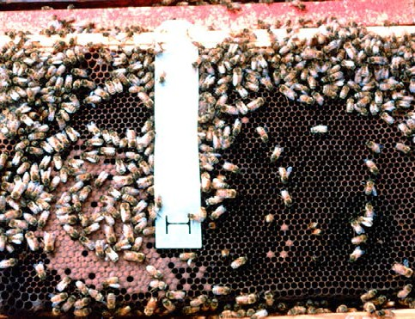
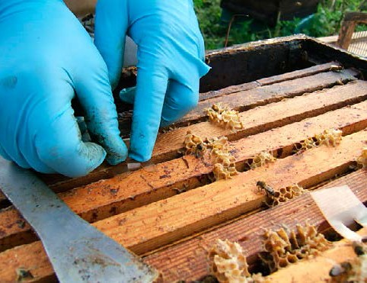
Mar Apr May Jun Jul Aug Sep Oct

Figures 42 and 43: Propriety varroacide treatment strips in use

Resistance management

Figures 44 and 45: Mite Away Quick Strips (MAQS) and Thymovar treatments

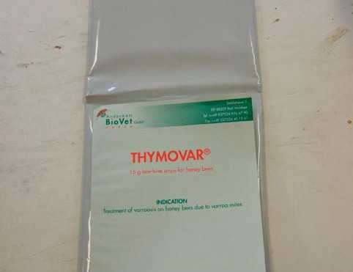
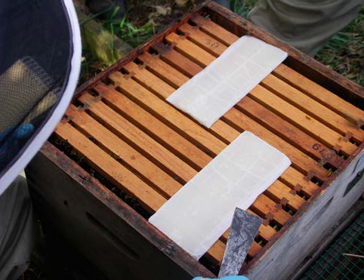
Oxalic and lactic acid require broodless periods to be effective and so are usually applied
very late or very early in the year. Generally beekeepers prefer to avoid treating during the active season when supers are on the hive,
to minimise the risk of leaving residues in bee products. However, some proprietary treatments can be used quite safely during a honey flow
if necessary (although not during comb honey production). The new Mite Away Quick Strips (MAQS) can be used in conjunction with honey comb production (Figure 44). This is useful
if unexpected serious infestation demands emergency treatment.

No mention of alternative, unauthorised, products in this leaflet should be taken as an endorsement of efficacy, safety, or a recommendation to treat. They are referred to because they are commonly available.
How does resistance arise?
Varroa populations will eventually develop resistance to any chemical varroacide (Figure 46). Individual variation within a mite population may result in small numbers of mites with resistant traits (e.g. a thicker cuticle that prevents entry of the active ingredient, or a metabolism that may break down the treatment before it does the mite damage). These characteristics are genetic and thus heritable, although often the mites with these unusual traits are reproductively weaker and are initially present as only a tiny proportion of the entire population.

When strong selection pressure is placed on the mite population, such resistant traits may begin to dominate. This can happen when a population of mites is repeatedly exposed to a varroacide, leaving more of the resistant mites alive to breed. Over many generations these mites will tend to become increasingly common until ultimately they comprise the majority of the mite population.

How long this process takes depends on how often Varroa mites are exposed to a varroacide and at what dose. Frequent treatments, especially when misused or when treatment strips are left in the colony for longer than recommended, accelerate the development of resistance.

Figure 46: Development of varroacide resistance. Initially only a very few mites are varroacide resistant. However, these mites and their offspring will survive successive treatments, and so over a period of time become more abundant. Eventually they will comprise the majority of the mite population
Figure 47: Map showing confirmed pyrethroid resistance in England and Wales (as of August 2009)

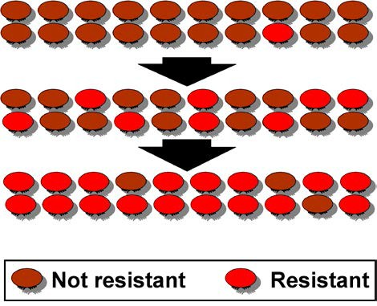
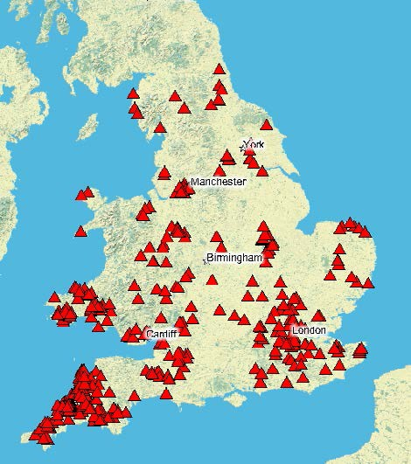
Pyrethroid resistance in the UK
It was always anticipated that Varroa would develop resistance to pyrethroids, which
are the active ingredients of the widely used varroacides Apistan and Bayvarol. In 2001, the NBU’s resistance surveillance programme (now discontinued) found the first confirmed
cases of pyrethroid resistance, in Devon. Figure 47 shows an example of confirmed resistance
in the recent past (2009). It illustrates the widespread nature of resistance once it occurs.

Responding to resistance spread
Beekeepers who have not yet detected pyrethroid resistant Varroa in their colonies should start preparing for their arrival without delay. Unless their presence is identified through resistance testing, the first obvious sign is likely to be the collapse of colonies after pyrethroid treatment fails to control mite infestation.

By the time resistant mites are identified in an apiary they generally comprise the vast

Avoiding Resistance
To delay the development and spread of resistance beekeepers should: treat with the specified dose
treat for the period specified

treat as little as necessary

alternate treatments (where possible) with one or more unrelated treatments

majority of the mite population. Beekeepers
who know they have resistant mites should stop using pyrethroids at once. These will no longer provide effective control and their continued use will only cause resistance problems to worsen. Instead, they should use a non-pyrethroid treatment, biotechnical methods, or both – ideally as part of Integrated Pest Management (see later section).

When pyrethroid resistance is widespread and most beekeepers are resorting to alternative non- pyrethroid varroacides, there is a significant risk that Varroa will also develop resistance to these products. This is the situation that now exists in several countries worldwide.

The strategies advocated in this leaflet to delay the development of pyrethroid resistance will apply equally to other
varroacides that may be used in the future. Ultimately, resistance monitoring is likely to be required for these also.

A range of other products is now being used by beekeepers. These are prescribed under the ‘Cascade’ system (see section ‘Using varroacides’, and the Bee Pages of the VMD’s website).

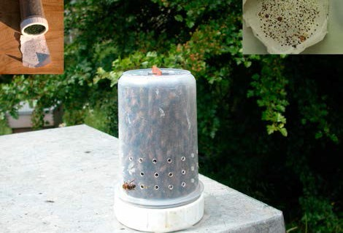
Should beekeepers suspect that any product they are using to treat Varroa is not working, this should be reported to the NBU immediately.

Figure48: Pyrethroidresistancetestkitinuse


Figure49:Mitesknockeddownontostickyinsert

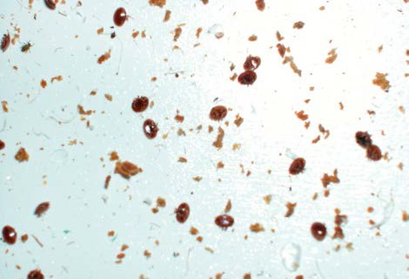
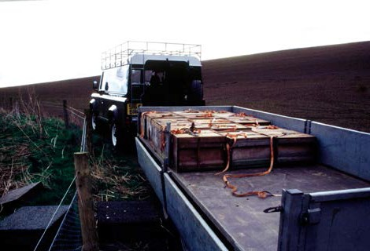
Figure 50: Heather moors produce an important UK honey crop, but are also areas where intensive migratory beekeeping is practised

Figure 51: Movement of colonies will speed up the spread of resistance. Be careful before moving or purchasing bees

Testing for pyrethroid resistance

Method: USDA Beltsville Test

- Cut a 9mm x 25mm piece from an Apistan strip and staple to centre of a 75mm x 125mm index card. Place card in 500ml jar with strip facing inwards.

- Prepare a 2–3mm light metal mesh cover for jar.

- Shake bees from 1–2 combs of a colony into an upturned roof. Scoop 1/4 cup of these (about 150) and place in jar.

- Place a sugar cube in jar. Cover with mesh lid and store upturned in dark, at room temperature.

- After 24 hours hit upturned jar with your palm over white paper three times. Count dislodged mites.

- Place upturned jar in a freezer, until bees are dead (1–4 hours). Count the remaining mites.
- Calculate percentage mite kill. Less than 50% indicates you may have resistant mites. Caution: This method gives only a crude indication of resistance and further confirmatory tests
are advisable. Discard results if the total number of mites per jar is below five.

Method: NBU Resistance Test

The NBU field resistance test is a modification of the Beltsville test using a purpose made test cage and low dose Apistan ‘Package Bee Strips’ (see Figures 48 and 49). The methods used is similar. However, a larger sample of bees is taken (approx 200), the test takes a shorter period (4 hours) and the bees are killed by immersion in soapy water, after which dead mites and bees are separated with a stream of water in coarse and fine sieves.

Method: Checking post treatment Varroa mite mortality

- Maintain colony on a mesh Varroa floor with collection tray beneath.

- Treat as usual with pyrethroid strips for 6 weeks.

- Clean tray and check daily mite drop immediately after treatment finishes.

- Significant mite drop indicates a mite population remains and therefore your treatment may not have been effective – requiring further investigation.

If you suspect mites are resistant to any other medicines being used this must be reported to the National Bee Unit, either to the laboratory at York (0300 3030094) or to your local Bee Inspector. Confirming resistance may need laboratory testing to be carried out.

Integrated Pest Management

What is Integrated Pest Management?
Integrated Pest Management (usually abbreviated to ‘IPM’) is a principle now widely used in agriculture, especially where it is desirable to keep chemical inputs to a minimum. Significantly, no attempt is made to completely eradicate the pests. Instead, the aim is to
keep them below the level where they cause significant harm, by using a combination of controls applied at different times of the year. More or fewer controls are employed depending on the levels of pests present. This is a much more effective approach than the alternative
of waiting until pest numbers have reached a damaging level before applying controls, or applying the same controls each year regardless of pest numbers.

Good husbandry
Good husbandry should be the starting point for IPM control of Varroa. Keep a close eye on the health of your bees and, in particular, make sure you can recognise the signs of Varroa infestation. Maintain apiaries to minimise the effects of robbing and drifting. Aim to keep
strong vigorous colonies and try to select strains that seem to show some Varroa tolerance.
An IPM programme for Varroa
IPM can be readily applied to control many bee pests and diseases, particularly Varroa. Potential benefits include:
Control at several points of the year makes it harder for the mite population to reach harmful levels
Use of management methods can reduce the need for varroacides
Using two or more unrelated varroacides will delay the development of mite resistance
Control strategies can be easily altered to reflect changing infestation levels

Unfortunately, there is no single IPM Varroa programme suitable for all circumstances. This is because there are enormous variations in infestation level, mite invasion, climate and beekeeping practices.

Figure 52 shows some of the combinations that are commonly used by beekeepers in the UK and overseas. Note that it would not normally be necessary or appropriate to use all the options. As a rule when infestation is serious more control and monitoring will be needed than at other times.

Figure 52: Examples of integrated control methods used throughout the year by UK and EU beekeepers (See Table 4 for information about authorisation for use of varroacides in Member States)
Control | Jan | Feb | Mar | Apr | May | Jun | Jul | Aug | Sep | Oct | Nov | Dec
Open mesh floor
Drone brood removal
Queen comb trapping
Formic acid/MAQS
Apiguard/Apilife VAR/ Thymovar
Apistan/Bayvarol/Apivar
Lactic/Oxalic Acid

Slowing down mite population growth
Employ methods that slow the growth of the Varroa population in your colonies – such as drone brood removal and use of mesh floors. These will have a less dramatic effect than other controls, but will delay the point when the infestation reaches a damaging level, allowing
you to treat a little later or to use less efficacious varroacides.

The effective use of open mesh floors (OMF) and drone brood culling should result in an efficacy of 50%. Comb trapping and control using the artificial swarm technique should result in an efficacy of 90% (Figure 53). Their use is helpful to reduce reliance on chemical controls, and can be essential where late crops such as heather or Himalayan balsam are sought.

Using monitoring to choose the level of controls to employ An important principle of IPM is to adjust the
level of control to suit the level of infestation.
Low mite levels need no action; intermediate levels may require some moderate intervention; high mite levels require more urgent and effective action.

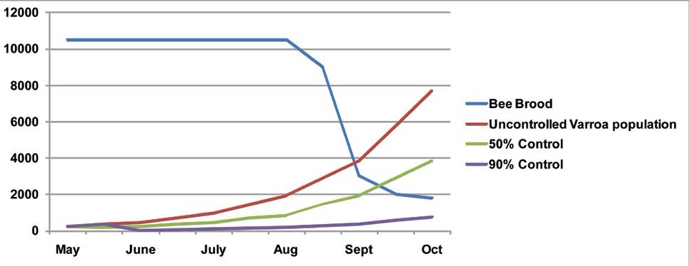
Figures 19 to 21, 54 and Table 5 illustrate these principles, using daily mite drop or drone brood monitoring to assess the severity of infestation and determine what action should be taken.
Figures quoted are based on the mathematical model of mite populations, and aim to maintain a level of less than 1000 mites/colony during the beekeeping season. However, be aware that the levels shown early in the season mean
that a colony is safe at that time but may require control before the end of the season, and also be aware that if an invasion of mites occurs then the mite levels could increase rapidly.

In this context, light control means using biotechnical methods or varroacides that have relatively low efficacy and therefore have a fairly limited effect on the mite population.
Effective control means using varroacides or biotechnical methods that are very effective and greatly reduce the mite population.

IPM Control Options
Figure 56 shows IPM control options when taking into account high, medium and low
levels of mite levels in a colony (as assessed by monitoring daily mite mortality).

In order to use this system you must first have a way of monitoring mite populations. This can be done from floor debris and daily drops from an OMF. Each day count the daily mite drop over
a period of a week. Use a sticky insert for solid floors, sticky side facing towards the frames, or the monitoring board with a sheet on top, coated with a layer of Vaseline to capture both dead
and live mites that fall down. Once you have ascertained a rough population level, use Figure 56 to devise a management system that best suits you.

Figure 53: The effects of application of biotechnical control methods on Varroa populations

Figure 54: Using mite drop monitoring to decide appropriate level of controls to employ

20

18

16
Natural Daily MiteDrop

14
12 Severe risk: effective controls required

10

8

6

4 Light control appropriate

2

Control not yet required

0
Jan Feb Mar Apr May Jun Jul Aug Sep Oct Nov

Dec

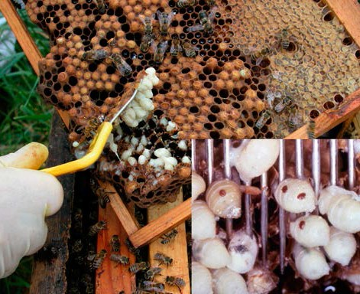

Table 5: Using drone brood monitoring to decide appropriate level of controls to employ

 | Proportion of infested drone pupae
April, May, June | Less than 2%  (<1 mite in 50) No action | 2% – 4%  (Between 1 mite in 25  and 1 in 50)  Plan controls for season | More than 4%  (>1 mite in 25) Consider control
June, July | Less than 3%  (<1 mite in 30) No action | 3% – 7%  (Between 1 mite in 15  and 1 in 30) Light control | More than 7%  (>1 mite in 15) Effective control Severe risk
August | Less than 5%  (<1 mite in 20) No action | 5% – 10%  (Between 1 mite in 10  and 1 in 20) Light control | More than 10%  (>1 mite in 10) Effective control Severe risk

Figures 55a and 55b: Drone brood uncapping, a popular and easy method for routine Varroa
monitoring. Varroa mites are easily seen against the pale drone bodies

Figure 56: IPM control options selected taking into account mite levels (as assessed by monitoring daily mite mortality and the time of year – as used by beekeepers in European countries
High Infestation

April May June July Aug Sept Oct Nov

Mite levels >8 >10 >4 >8 Drone Brood Removal
If the mite drop in a colony is >15 mites per day you must do something and treat immediately
Other Management
Methods
High Efficacy Varroacide Lactic/Oxalic Acid

Medium Infestation

April May June July Aug Sept Oct Nov

Mite levels >4<8 >6<10 >4 >8 Drone Brood Removal
Other Management Methods

Appropriate Varroacide Lactic/Oxalic Acid

Low Infestation

April May June July Aug Sept Oct Nov

Mite levels <2 <6 <4 <8 Drone Brood Removal

Living with Varroa

The experience of beekeepers in the UK dealing with Varroa has changed significantly over the period since the mite’s initial discovery.

For the first few years, most beekeepers found Varroa relatively easy to control with a single autumn treatment, often applied quite late in the season. However, this was followed by an acute phase in which Varroa became much harder to control as mite levels were unexpectedly found to increase quickly. In particular, this occurred where untreated managed and feral-colonies respectively, were causing mite invasion problems. Beekeepers then found that it was vital to treat quickly after the end of the honey flow in late summer and, in some cases, again in the spring. Many who delayed treatment, or
used controls that were not sufficiently effective, lost their bees – up to 50% of colonies in some areas.

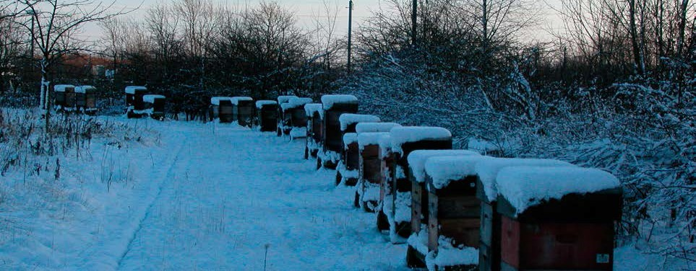
After this phase of widespread losses, beekeepers found that Varroa again became somewhat easier to control – probably because
mite invasion had reduced following the loss of feral or poorly managed colonies. For a period of several years colony losses due to Varroa were relatively infrequent. However, mite levels sometimes still increased, requiring a swift and effective response.

The development and spread of pyrethroid resistant Varroa has presented beekeepers with serious and significant new challenges. Beekeepers now find Varroa difficult to control, and some have lost their colonies to the infestation.
As resistance is spreading, all beekeepers
are having to learn and adopt new methods of monitoring and controlling the infestation in their hives. However, the experience of beekeepers coping effectively with the development of resistance demonstrates that they are able to adapt to the changing circumstances, and to continue beekeeping as successfully as ever.

Figure 57: It is vital that honey bee colonies go into the autumn and winter with young healthy bees and low mite populations

Key strategies for effective Varroa control

- Monitor the infestation in your hives. You need to know if the mite population is building up faster than you thought or your treatments are not proving effective. Don’t just treat and leave it to chance.

- Talk to other local beekeepers about the Varroa problems you experience and the control strategies you are using. It may then be helpful to work together – for example in co- ordinating treatments.

- Practice Integrated Pest Management (IPM) using a combination of varroacides and biotechnical methods. This will give the most effective control.

- Slow the development and spread of resistant Varroa and minimise the risk of treatment residues by treating no more often than is necessary – monitoring will help you decide how often this should be.

- Use UK authorised varroacides. These have proven efficacy against Varroa and proven safety for bees, beekeepers, consumers and the environment. Always follow the label instructions.

- Where possible rotate the use of two or more unrelated varroacides (i.e. varroacides with different active group ingredients). This is an effective strategy to slow the development of resistance. Avoid using the same varroacide year after year.

- Remember that the use of unauthorised chemicals in your colonies or the misuse of authorised varroacides may leave harmful and detectable residues in your bee products.

- Be prepared to check for Varroa resistance. Learn to test for resistance and gain experience of using other controls. When resistance arrives you will have to stop using those medicines to which mites are no longer susceptible, and rely on alternatives.

- Be flexible and adaptable in your control of Varroa. Methods that work well in some circumstances may not work well in others.

- Keep up to date with new developments in the control of Varroa – as the situation develops you need to make sure you have the latest information to help you respond appropriately.

- Select for and retain bees that appear to show increased tolerance to Varroa.

Looking ahead

New developments in Varroa

management
Over the coming years we can expect new developments that will change the way we control infestation with Varroa. These are likelyto include:

New varroacides
Most are likely to be based on active ingredients of existing veterinary medicines and pesticides re-formulated for Varroa control. Novel varroacides based on other (often naturally occurring) active ingredients are also under development.

New treatment systems
The development of methods for administering existing varroacides, particularly organic acids, to allow safer and more effective controls with fewer adverse effects.

Pheromones
The development of synthetic pheromones (natural chemical messages) to provide control over Varroa – for instance by inhibiting their feeding or reproduction.

Biological controls
Research continues to identify naturally occurring fungi and bacteria that could kill Varroa mites within the bee colony, and to develop these into practical control methods.

Predatory mites
A species of Strateolaelaps mites native to the UK has been used to biologically control pests in horticulture for over 15 years.
Recently, this species has been trialled
in colonies of Apis mellifera to control the population of Varroa mites. Strateolaelaps mites attack the phoretic (adult) stages of Varroa and maintain populations to a level which do not cause any significant health problems to the colony.

Such biological controls are only effective when treatments are administered during periods where the pest species levels are low. As a result, they are ineffective when treating a heavily infested colony. Trial work is at an early stage but preliminary results show that colonies treated with predatory mites have a consistently low level of Varroa when compared to untreated hives.

Biotechnical techniques
Development of more sophisticated and effective biotechnical controls. These are likely to become part of routine colony management.

Tolerant bees
Breeding and research programmes in many countries are aiming to select and develop bees that are more tolerant of Varroa. These bees may either be able to naturally maintain better control over themite population, or
may be more tolerant to the presence of the mites and their associated pathogens.

Breeding disease-resistant ‘hygienic’ honey bees
The University of Sussex is running a project that identifies ‘hygienic’ colonies. It believes that only10% of British hives (Apis mellifera mellifera) are hygienic and has developed behavioural tests that identify hygienic traits or behaviours in adult worker bees. Queens from the same patriline are then selected, a process known as ‘intracolony selection’ and reared in a honey bee breeding programme.
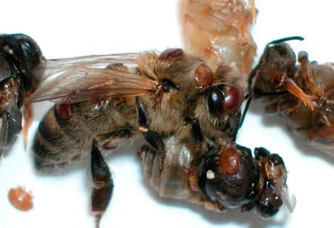
Intracolony selection enables the breeder to focus on parts of the colony that have desirable traits and it is hoped that by focusing on the hygienic trait, worker bees will remove more dead or infected larvae from their cells and reduce the spread of diseases within the colony.

Figure 58: In the future bees may become more tolerant of Varroa and mites may become less virulent, leading in time to more of an equilibrium between host and parasite

Useful addresses

National Bee Unit (NBU), National Agri-Food Innovation Campus,
Sand Hutton, York, North Yorkshire, YO411LZ
Tel: 0300 303 0094
Fax: 01904 462240
Email: nbu@apha.gsi.gov.uk
Web: www.nationalbeeunit.com

Office of the Chief Veterinary Officer
Welsh Assembly Government Officer
Hill House Picton Terrace Carmarthen SA31 3BS Tel: 01267 245 007
Web: www.wales.gov.uk

Scottish Government
Pentland House 47 Robbs Loan
Edinburgh EH14 1TY Tel: 0131 244 6178
Web: www.scotland.gov.uk

Science and Advice for Scottish Agriculture SASA, Roddinglaw Road Edinburgh EH12 9FJ
Tel: 0131 244 8890
Fax: 0131 244 8940
Email: info@sasa.gsi.gov.uk
Web: www.sasa.gov.uk

Chemicals LAIF Industria Bio-chimica Via dell’artigianato, 1335010 Vigonza (PD) Italy
Web: www.beekeeping.org/ chemical-laif/index.htm

World Organisation for Animal Health
Office International des Epizooties (OIE)
Web: www.oie.int

Department of Agriculture and Rural Development
Northern Ireland (DARDNI) Dundonald House,
Belfast BT4 3SB, Northern Ireland Tel: 02890 24488
Web: www.dardni.gov.uk
Defra Veterinary Medicines Directorate
Woodham Lane New Haw Addlestone Surrey KT15 3LS
Tel: +44 01932 336911
Web: https://www.gov.uk/ government/organisations/ veterinary-medicines-directorate

British Beekeepers’ Association (BBKA) (county and local beekeeping associations)
National Agricultural Centre, Stoneleigh Warwickshire, CV8 2LG
Tel: 08718 112282
Web: www.bbka.org.uk

Scottish Beekeepers’ Association
Email: secretary@ scottishbeekeepers.org.uk
Web: www.scottishbeekeepers. org.uk

World Organisation for Animal Health
Office International des Epizooties (OIE)
Web: www.oie.int

Office of Public Sector Information
(European Community and UK Legislation)
Web: www.opsi.gov.uk/

Ulster Beekeepers’ Association
Web: www.ubka.org

Bee Farmers’ Association (BFA)
Web: www.beefarmers.co.uk

International Bee Research Association
(library and beekeeping information services) Unit 6, Centre Court Main Avenue Treforest CF37 5YR
UK
Tel: 02920 372409
Web: www.ibrabee.org.uk/
Welsh Beekeepers’ Association
Web: www.wbka.com/

Vita (Europe) Ltd 21/23 Wote Street Basingstoke Hants RG21 7NE
Tel: +44 (0)1256 473175
Fax +44 (0)1256 473179
Web: www.vita-europe.com

MAQS NOD Europe Ltd
5 St Paul’s Square Old Hall Street
Tel: +44 (0)1630 655722
Email: info@nodglobal.com
Web: www.nodglobal.com

Bayer (UK and Ireland) Ltd
Web: www.bayer.co.uk

Biové Laboratoires Biové Rue de Lorraine
P.O. Box 45
62510 Arques France
Web: www.beekeeping.com

BioVet
Tel: +41 (0)62917 5110
Email: info@biovet.ch
Web: http://www.biovet.ch/en/ Imkerei/thymovar.html

European Community and UK Legislation
The Stationery Office
51 Nine Elms Lane London SW8 5DR
Tel: +44 0870 600 5522
Web: www.legislation.gov.uk/uksi

Bee Disease Insurance Ltd (BDI)
Registered Office
National Beekeeping Centre, NAC Stoneleigh Park
Warwickshire CV8 2LG Tel: 08718 112337
Web: www.beediseasesinsurance. co.uk

References and Acknowledgements

References
A number of references were used in the development of this advisory leaflet and/or may be useful as further sources of information:
Anderson D.L., Trueman J.W.H. (2000) Varroa Jacobsoni (Acari : Varroidae) is more than one species. Experimental and Applied Acarology 24: 165-189.
Anton I., et al, Alternative Varroa Control, Federal Diary Research Institute, Liebefeld, Switzerland
http://www.users.globalnet.co.uk/~msbain/elbka/Varroa%20IPM%20Controls%20Papers.htm
Calis J.N.M., Boot W.J., Beetsma J., van den Eijnde J.H.P.M., de Ruijter A., van der Steen J.J.M. (1998) Control of Varroa by combining trapping in honey bee worker brood with formic acid treatment of the capped brood outside the colony. J. Apic. Res. 37(3): 205-215.
Calis J.N.M., Boot W.J., Beetsma J., van den Eijnde J.H.P.M., de Ruijter A., van der Steen J.J.M. (1998) Effective biotechnical control of Varroa. J. Apic. Res. 38(1-2): 49-61.
Charrière J.D., Imdorf A., Bachofen B., Tschan A. (2003) The removal of capped drone brood: an effective means of reducing the infestation of Varroa in honey bee colonies. Bee World 84(3): 117-124.
Dietemann V., et al (2012) Varroa destructor: Research Avenues Towards Sustainable Control, IBRA, 51(1): 125-132
Donzé G., Guerin P.M. (1994) Behavioural attributes and parental care of Varroa mites parasitizing honey bee brood. Behav. Ecol. Sociobiol. 34: 305-319.
Frey E., Odemar R., Blum T., Rosenkranz P. (2013) Activation and interruption of the reproduction of Varroa destructor is triggered by host signals (Apis mellifera). Journal of invertibrate Pathology. 113 56-62.
Gallai N., Salles J.M., Settele J., Vaissière B.E. (2009) Economic valuation of the vulnerability of world agriculture confronted with pollinator decline. Ecological Economics (NLD): 810-821.
Goodwin N., Eaton C.V. (1999) Control of Varroa, A Guide for New Zealand Beekeepers Ministry of Agriculture and Forestry. www.biosecurity.govt.nz/files/pests/varroa/control-of-varroa-guide.pdf.
Klein A.M., Vaissière B.E., Cane J.H., Steffan-Dewenter I., Cunningham S.A., Kremen C., Tscharntke T. (2007) Importance of Pollinators in changing landscapes for world crops. Proc. Biol. Sci. 274: 303-313.
Martin S.J., Highfield A.C, Brettell. L., Villalobos E.M., Budge G.E., Powell M., Nikaido S., Schroeder D.C. (2012) Global honey bee viral landscape altered by a parasitic mite. Science, 336.
OIE (2008) Varroosis of honeybees. OIE Terestrial Manual Chapter 2.2.7.
http://www.oie.int/fileadmin/Home/eng/Health_standards/tahm/2.02.07_VARROOSIS.pdf
Rosenkranz P., Aumeier P., Ziegelmann B. (2010) Biology and control of Varroa destructor. Journal of Invertebrate Pathology 103: S96-S119. www.elsevier.com/locate/jip
Thompson H.M., Brown M.A., Ball R.F., Bew M.H. (2002) First report of Varroa destructor
resistance to pyrethroids in the UK. Apidologie 33: 357-366.
Wilkinson D., Smith G.C. (2002) A model of the mite parasite Varroa destructor on honey bees (Apis mellifera) to investigate parameters important to mite population growth. Ecological Modelling 148: 263-275.

Acknowledgements
Leaflet updated by Mike Brown, Michael Birt, Jason Learner, and Jack Wilford of NBU, on behalf of Defra and the Welsh Assembly Government. All photographs (unless specified) supplied by National
Bee Unit. David Crossley is the Fera Science Limited photographic contact. Additional technical information supplied by Ivor Flatman, Richard Ball, Selwyn Wilkins and Andrew Wattam. Leaflet design by www.williamslea.com


Animal &
Plant Health Agency
© Crown copyright 2015
2904119 Produced by Williams Lea for the Department for Environment, Food & Rural Affairs

