Facial Toner

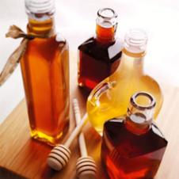

Ingredients

* 1 Tablespoon - honey
* 1 - apple, peeled and cored

Directions

In blender, puree honey with a peeled, cored apple. Smooth over face; leave on 15 minutes. Rinse with cool water.