Gentle Honey Cleanser

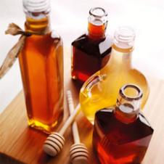

Ingredients

* 1/4 cup - honey
* 1 Tablespoon - liquid soap
* 1/2 cup - glycerine (available at drug and beauty stores)

Directions

Mix all ingredients together in a small bowl until they are fully blended. Pour into a clean plastic bottle. Pour onto clean face sponge or soft cloth and gently rub onto face, wash away with warm water and pat face dry. Enjoy fresh radiant skin.

TIP

This cleanser is simple and effective. The soap gently cleans, the glycerine prevents drying and the honey not only softens the skin, but its antimicrobial properties can help ward off breakouts. A touch of honey is all you need for healthy, glowing skin.