Grilled Honey-Glazed Pork Tenderloin with Onions.

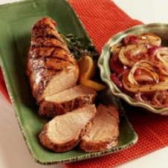

Serves: 4 TO 6 SERVINGS

Ingredients

* 1/2 cup - Buckwheat honey
* 1/4 cup - extra-virgin olive oil
* 1/4 cup - cider vinegar
* 1 Tablespoon - minced garlic
* 2 teaspoons - Herbes De Provence seasoning mixture
* 1 teaspoon - salt
* 1/2 teaspoon - pepper
* 2 lbs. - pork tenderloin
* 3 medium - onions

Directions

Combine honey, oil, vinegar, garlic, herbs, salt and pepper in a shallow pan. Add pork and turn to coat it well. Cover and refrigerate 2 to 4 hours. Turn pork occasionally. Remove pan from refrigerator 30 minutes before grilling. Prepare grill for a medium-hot fire with an indirect heat area. Slice onions in rounds 1/2 to 3/4-inch thick. Remove pork from marinade and boil marinade 1 minute. Taste and add more salt if needed. Grill pork over indirect heat, covered, until the middle is about 145°F, 25 to 30 minutes. Brush pork generously with the marinade; turn every 10 minutes to evenly cook. Put onions over direct heat and brush with marinade. Turn frequently, brushing with marinade, until well-marked and soft, 8 to 12 minutes. Move onions off direct heat to finish cooking. Let pork rest 5 minutes before slicing into 3/4-inch thick slices. Serve with grilled onions.