Hair Shine

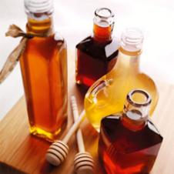

Ingredients

* 1 teaspoon - honey
* 4 cups - warm water
* Lemon (for blondes)

Directions

Stir honey into warm water. Blondes may wish to add a squeeze of lemon. After shampooing pour mixture through hair. Do not rinse out. Dry as normal.