Honey Cleansing Scrub

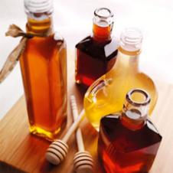

Ingredients

* 1 Tablespoon - honey
* 2 Tablespoons - finely ground almonds
* 1/2 teaspoon - lemon juice

Directions

Mix all ingredients. Rub gently onto face. Rinse off with warm water.