Honey-Cinnamon Emollient Night Mask

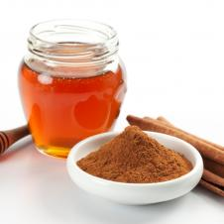

Overnight treatments are recommended to deeply nourish your face. Try this mix of two very simple and accessible ingredients.

YIELD: MAKES TWO APPLICATIONS

Ingredients

* 2 tablespoons - honey
* 1 teaspoon - cinnamon

Directions

In a small container, add honey and cinnamon and mix until it forms a paste. Apply emollient onto face before going to bed and leave on all night. Rinse with warm water the next morning. As a second option, apply paste and leave on for 30 minutes before rinsing with warm water.