Hydrating Eyelash Honey Balm & Makeup Remover

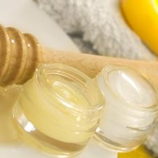

Tired of using an eye makeup remover that irritates your eyes and skin? This one isn’t just gentle; it also soothes the skin around your eyes, as well as your eyelashes.

YIELD: MAKES TWO APPLICATIONS

Ingredients

* 1 teaspoon - honey
* 3 teaspoons - castor oil

Directions

In a small bowl, combine honey and castor oil. Cover mixture and allow to settle for one week in a cool area, mixing it every so often until a homogenous solution is achieved. Use every night to remove mascara and eye makeup while nourishing lashes.