**June tips.**

The swarming in season is now with us, and if you have not done a method of swarm control which you should have done in mid-May, you will have to do it now. I will not go into the different methods as I did it in the May issue of May tips and would only be repeating ourselves. Just make sure that it is done. It’s should not need doing on any new bees bought this year which are in Nucs, but any established bees will need to be done. Otherwise you have a real chance of the swarming.

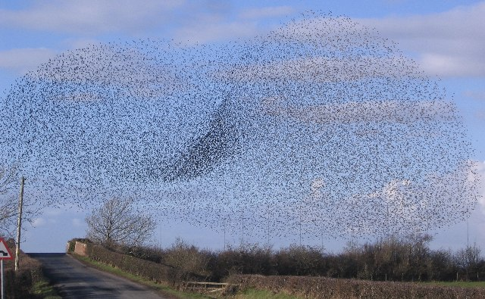

A little bit on swarming and why you should not allow it to happen. Firstly only the flying bees leave the hive with the queen, so what you have is all the honey producers, leaving the hive, eating as much honey as the can, as they don’t know when the next meal is coming from. So you have lots of honey being taken from the hive and all production stopping. Not a good situation if you want honey at the end of the season. In the hive you have all the house bees looking after the young, again eating all the honey. A virgin queen who may take a few weeks to start to lay, so not eggs produced and a hive decreasing all the time. Also the bees that are left can be a problem for your neighbours and will probably not survive. Really it bad management and irresponsible beekeeping Remember also that although you have done your artificial method of swarm control, you will still need to look for queen cells, if done ok they will more than likely be Ok but like other things with bees you can never tell, so it’s best to check. Bees have to swarm otherwise they would die out so there is no way you can stop it happening.

Your bees should be building up nicely now and should not, if the weather is good need feeding, do remember though that this is not always the case and there is a phenomenon called the June gap where your bees can actually starve. It’s just a matter of looking at the weather, looking in your hive and accessing the situation and if feeding is needed, then feed and if in doubt feed. Best to feed with a sugar/syrup solution of 1:1 and feed till the bees stop taking it. Also never feed your bees if you have supers on as they will put it into the super, making the honey rubbish. If things are ok you will need to add supers so as to give the bees room to store the honey that you will be taking off later in the year. Start with just the one and add as necessary.

You should be ok around here in Lancashire just with one brood box as unlike further down south the bees do not build up to quickly. I think personally that using, brood and a half, which is when you have a national brood chamber and a super together to give the bees more room is hard work. I personally do not like this method as it means going through 2 boxes the find the queen, queen cells or just to check what is going on in your hive, its hard work when you are doing swarm control too. What I tend to do is use a commercial brood box or a deep national brood box. You can always use dummy frames at the beginning or end of the season, or if your bees are not too strong, and then take them out as the colony builds up. Although a little heavier it’s still a lot easier when you are going through the bees.

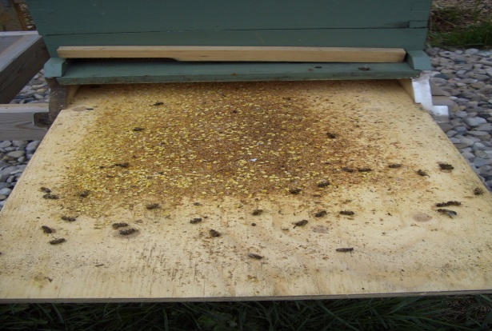

Watch out now for Varroa and check every week has according to the man from the ministry, who has been sending out e-mails to those of us who are registered on Bee Base, that due to the warm winter where the queen as kept on laying instead of having here usual rest which has ended up with large colonies early on with equal if not more Varroa than bees. There are lots of things you can do to knock the little buggers down, but now according to the powers that be we are only allowed to use what you can buy and not use anything you make up yourself. Here is a summary of what and what you cannot use and where to get it.

**There is a lot of confusion on what legal products we can use to treat our bees. Below is a summary of what we can use up to date (May 2014).I have put in the**

* **Veterinary Medicines Regulations (VMR) 2013**
* **The list of products you can use**
* **A list of products you can use from abroad.**
* **What is illegal to use in the UK**

**Veterinary Medicines Regulations (VMR) 2013**

The VMR state that if an animal or animal product is to be put into the human food chain, then:

* only authorised veterinary medicinal products can be administered in accordance with the label instructions should be used;
* Products administered in accordance with an animal test certificate may be used.

**Honey bees are classed as a food producing animal and therefore beekeepers must comply with these regulations. Generic substances such as Oxalic acid or self-made Thymol solutions should not be used and beekeepers are liable for prosecution if traces are found during routine honey sampling. It is important to note that some products available on beekeeping manufacturer’s websites are not registered medicinal products and although available, should not be used.**

**Authorised products**

A list of authorised medicines for honey bees can be found on the '[Product Information Database](http://www.vmd.defra.gov.uk/ProductInformationDatabase/Default.aspx)' on the VMD website. To find products relating to bees only, use the [product search facility](http://www.vmd.defra.gov.uk/ProductInformationDatabase/Search.aspx) and select 'bees' from the species drop down box.  
  
Currently, there are no UK registered oxalic acid treatments for honey bees. However, beekeepers are able to apply for EU approved medicines which are available in EU Member States through a Special Import Certificate (SIC). There are a two registered oxalic acid medicines available to beekeepers and a list of products available under this scheme can be found [here](http://www.vmd.defra.gov.uk/public/bee_authorised.aspx).  
  
Api-Bioxal is a registered oxalic acid treatment in Italy and Ecoxal is a registered oxalic acid treatment in Spain. These are both available under the scheme and you can either ask your local vet whether they take part in the scheme or you can buy Api - Bioxal directly from [Bee Vet](http://www.bee-vet.co.uk/).  
  
To view a list of veterinary surgeons with knowledge in apiculture, click [here](https://secure.fera.defra.gov.uk/beebase/downloadDocument.cfm?id=354).

**Medicine record card**

The beekeeper must keep the documentation containing details of a veterinary medicinal product and the records relating to the product for at least five years following the administration or other disposal of the product, irrespective of whether or not the colony concerned is no longer in that keeper’s possession or has died during that period.  
  
When a veterinary medicinal product is bought beekeepers must, at the time, record:   
  
(a) the name of the product and the batch number;   
(b) the date of acquisition;   
(c) the quantity acquired; and   
(d) the name and address of the supplier.  
  
When administering the medicine, beekeepers must record on a medicine record card:   
  
(a) the name of the product;   
(b) the date of administration;   
(c) the quantity administered;   
(d) the withdrawal period; and   
(e) the identification of the animals treated.  
  
A beekeeper who disposes of any or the entire veterinary medicinal product other than by  
treating a colony must record:   
  
(a) the date of disposal;   
(b) the quantity of product involved; and  
(c) how and where it was disposed of.

**This is what we can use legally in the UK.**

**Apiguard Gel 25% Thymol**

**Apilife Var Bee-Hive Strip Camphor Racemic, Eucalyptus Oil, Menthol Levo, Thymol**

**Apistan 10.3% w/w Bee Hive Strip Tau Fluvalinate**

**Bayvarol 3.6 mg Bee-hive Strips  Flumethrin**

**MAQS Formic Acid 68.2g Beehive Strips  Formic Acid**

**Thymovar 15 g Bee-hive Strips Thymol**

The products below can be used in the UK, but are only available on prescription from a vet with a Special Import Certificate (SIC).

Api-Bioxal is a registered oxalic acid treatment in Italy and Ecoxal is a registered oxalic acid treatment in Spain. These are both available under the scheme and you can either ask your local vet whether they take part in the scheme or you can buy Api - Bioxal directly from [Bee Vet](http://www.bee-vet.co.uk/) who will ask you to register with them ask you a few questions and then let you have it. Really strange as with oxalic acid you can buy it anywhere but cannot use it unless you register with a vet with a Special Import Certificate (SIC).

|  |  |  |  |  |
| --- | --- | --- | --- | --- |
| **Product** | **Active Substance** | **Manufacturer** | **Pharmaceutical Form** | **Imported From** |
| **Checkmite + \*** | **Coumaphos** | **Bayer Animal Health** | **Impregnated Strips** | **Greece** |
| **Apivar** | **Amitraz** | **Veto-Pharma SA** | **Impregnated Strips** | **France** |
| **Formidol** | **Formic Acid** | **Bee Research Institute** | **Evaporative Board** | **Czech Republic** |
| **Ecoxal** | **Oxalic Acid** | **Ceva Salud Animale SA** | **Powder** | **Spain** |
| **API-Bioxal** | **Oxalic Acid Dihydrate** | **Chemicals Laif** | **Powder** | **Italy** |

* **What is illegal to use in the UK**

**Any other product that is not listed above is illegal and if a government official finds any residues of any other product in your hives you could be in trouble.**

**It’s all a bit confusing really as some member states of the EEC can use stuff that we can’t use. We are all supposed to be in it together so why this is so is a bit of a mystery.**

**Also most of the products that are allowed are made by the big pharmaceutical companies who love to control the market and are not interested in products such as Oxalic Acid, which do knock down Varroa, but would not make them any money.**

**You would think that the legislation would be about protecting the bees and not the big pharmaceutical companies, but I afraid it does not seem the case.**

**But the law states that**

**Generic substances such as Oxalic acid or self-made Thymol solutions should not be used and beekeepers are liable for prosecution if traces are found during routine honey sampling. It is important to note that some products available on beekeeping manufacturer’s websites are not registered medicinal products and although available, should not be used.**

**So to summarise.**

**You can buy and use all the products in table 1 without getting into trouble with the Law**

**You can buy and use the products in Table 2 if you buy from a vet** **with a Special Import Certificate (SIC).**

**If you use any products from table 1 and 2 you must fill in a medical records for as stated in the**

**Veterinary Medicines Regulations (VMR) 2013**

**A good supplier of medicines from a registered vet is from.**

**The BeeVet**

**At**

**Contact**

For bee medicines enquiries please call us on **01392 872887**  
  
or email us at [**info@bee-vet.co.uk**](mailto:info@bee-vet.co.uk)

You will have to register with them before you can buy anything.

All very confusing and complicated but we must remember we have to protect the companies who make these products as we as beekeepers know bugger all about anything. And like the old saying goes, more wants more.

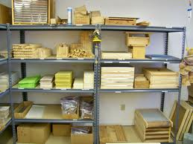

Make sure you have enough equipment too, you can never have enough. The rule is to have an extra set for each have but more the merrier really as you never know if you will need it and to be caught out can be frustrating. If you don’t need it you are always content in your mind that if you no it’s always there for you. If you do need it you will be glad you took this little bit of advice.

**New Beekeepers**

Many of you newbies will now be getting your first lot of bees; I hope that before you have bought them that you have had some kind of training. Many would be beekeepers start off knowing nothing and soon get into real trouble with your bees and in the end lose them or get fed up with them due to the fact that they cannot handle them... Think about it before you buy any as it’s an expensive hobby but more important you are dealing with animals who need to be looked after properly, by someone who as a basic idea of what they are doing, so that the bees are treating kindly and with some degree of experience, I am not taking about being like someone who has kept bees for years, but the basics will be enough.

Go to your association or club and listen to what the speakers and the experienced beekeepers are talking about, and don’t be afraid to ask, no one will laugh at you; we have all been there at some time. Buy your bees locally if you can as you have a good idea where they have come from and how they are and very importantly know that they are free from disease. The bees will also be used to living in Lancashire which we all know can be harsh place weather wise.

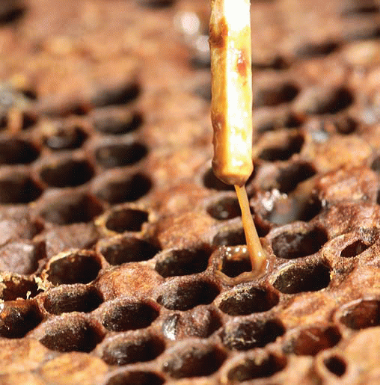

There are many bees from away which have both American and European foul brood which are both naughty and are notifiable diseases, where you have to contact the local bee inspector, so be careful where you buy from as you could be heading for trouble.

Ok you all take care. The next tips will be next month where I will be in the Far East, so you all take care and hope the weather is kind to you and your bees

**Michael**