Simple and Safe Varroa Mite Control
My description below of what I thought was an original idea- until I saw a similar idea on an American website.
My intention was to bring it to the attention of fellow beekeepers who maybe wanted to try it out as I have
done- successfully I might add!!!
It works by forcing the honey bee to stoop and squeeze through a gap. This precise measured gap (known throughout beekeeping as the 'bee space' ) does not inhibit its entry or exit, but by making this space just less than the 'bee space' means that the bees back (thorax) rubs against the entry/exit brushes, knocking off any varroa mites. The bee exits and enters the hive hundreds of times a day (weather permitting) and so increases the likelihood of catching a mite at some point. Once the mite is knocked off the bee, it falls through the hive meshed floor onto a sticky board, thus preventing it climbing back into the hive. In fact, the existing sliding varroa floor can be smeared with petroleum jelly or similar for the mites to stick to
Parts; approx.17 inch length of door draught excluder brush.
An 18 inch piece of wood batten to fix the brush to using 4 bee pins (small nails)
Small amount of petroleum jelly or similar to smear onto the already positioned board below the hive base
The brush is placed at the entrance of the hive and fixed in place by one small screw
TOTAL cost £3 per hive max
First of all, before we start- there are always varroa mites in the hive. BUT- the fewer the better
It will lessen the amount of varroa mites in the hive which are arguably the biggest problem the bees have at present and are causing the decline of their population. The mites nibble at the bees in their larvae stage whilst still in the cells. This results in dead or deformed bees. If the mite numbers reach a certain level in the hive, the hive collapses and dies. By knocking the mites off in this way, it does away with the need to treat the bees for this pest with chemicals such as Oxalic acid. In red is a statement from a well-known beekeepers site, David A Cushman. Other treatments affect the bees in many ways but the brush has no detrimental effect at all. Importantly, the hive does not have to be opened to check for infestation or to treat it. Before the winter, bees glue up any draughty gaps in the hive, particularly the lid. In Dec beekeepers open the hive, breaking this gap and pour oxalic acid onto the bees to kill the mites. They then replace the lid, by no means sealing the gaps and leave the bees for the rest of the winter with those draughts. This cooler hive results in a later start to the season and the laying of the spring bees. The brushes can be left on all year. Oxalic acid, formic acid, lactic acid, Chemical strips, chemical pastes in the feed all have to be used BEFORE, and I stress before the 'SUPERS' (these are the top boxes added to the top of the hive. from which we take the honey for consumption), the beekeeper can add these top boxes, otherwise the treatments end up in the food chain. Honey production is slowed down by all other treatments but not the simple entrance / exit brush
It cannot be stressed too strongly that oxalic acid is an aggressive substance and needs to be treated with respect. Acid resistant gloves and goggles should be worn and an apron of the type used by mortuary attendants, along with wellington boots that have the tops covered by gaiters so that any falling liquid cannot fall into the boot. A respirator that has specialised organic acid filtering will be required in cases where the acid is sprayed or vaporised. Oxalic acid is also poisonous to humans by ingestion.
The same warning is given for the other acids
The most important features are: NO opening hive to sprinkle with talcum powder, icing sugar, pouring acids or spraying acids or heating acids up and fumigating hive with the resultant fumes, bee friendly herbs to encourage bees to clean more frequently, placing chemical plastic strips into the hive right into the centre of the brood pattern, only to be removed after 2 weeks-- plus all the other methods. All methods involve opening up the hive and disturbing the bees, inevitably killing some in the process. In my tests watching the bees in and out of the hive, they accept the entrance brush as being part of the hive and are not affected by it in the slightest.

Another point to note. Drones. How do they get through this smaller opening? The answer is that they don't. A small amount of the brush is cut out to leave a gap large enough for a drone to get through. The females wont queue up to use this gap due to the numbers entering and exiting. They still squeeze through the entire entrance length and have their thorax brushed.
Note: the height adjustment to get the brush at just less than the bee space is very easy to sort, but not as easy to type!
Give me a ring on where to get the materials to make one. 07954585019
Steve Ganner

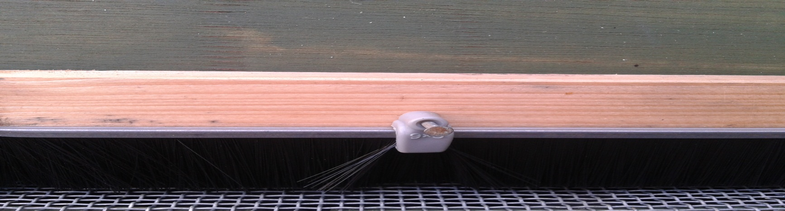

Long Bristle Fixed at the entrance.
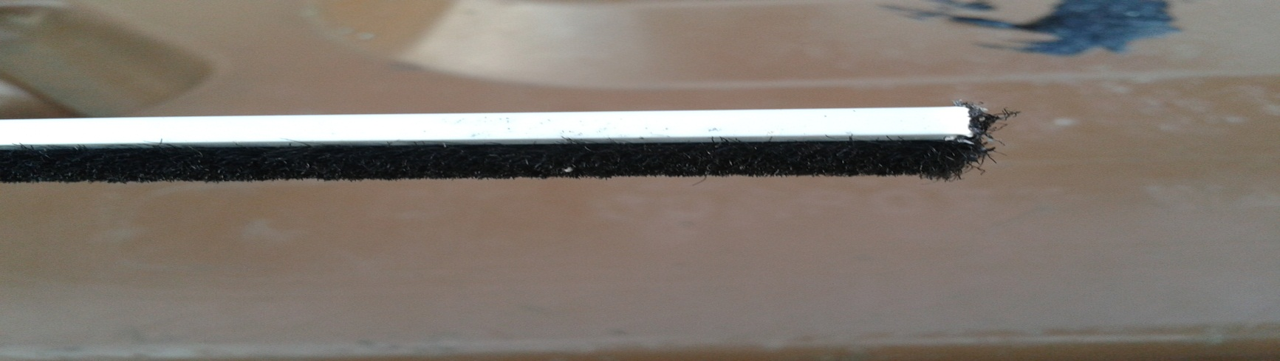
Short Bristle

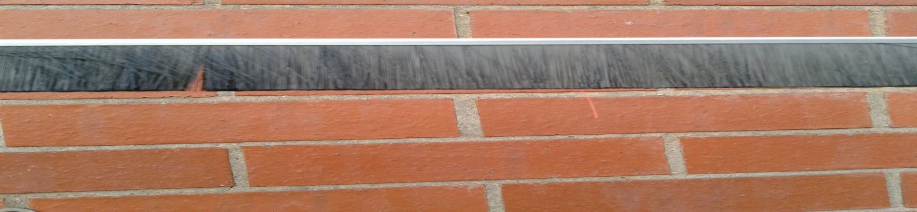
Long Bristle

