Spiced Mandarin Orange Tea with Honey

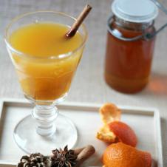

YIELD: 4 SERVINGS

Ingredients

* 4 tbsp. - honey
* 12 mandarin oranges  - juice , (with the pulp)
* 4 mandarin oranges - rind
* 4 cups - water
* 4 - star anise pods
* ½ tsp.  - nutmeg, ground
* ½ tsp.  - cinnamon, ground
* 1 - cinnamon stick
* 1 tbsp. - vanilla extract
* extra cinnamon sticks , (optional garnish)

Directions

Place all of the ingredients in a medium-sized saucepan. Cover with lid and heat over high heat. Stir every so often and bring to a boil. Turn the heat to low and boil for another 30 minutes without lid, until all the flavors are well combined and the aroma of the spices is strong.

Before serving, strain the tea to remove the pieces of rind and any residue. Serve hot and decorate each cup with a stick of cinnamon if desired.